Optimization and Bio-Inspired Decision Making:
Hybrid Genetic Algorithms for the Traveling Salesman Problem

Dustin Hinson, RET Teacher
Marcia Roth, RET Teacher
Anoop Sathyan, P.hD. student, Aerospace Engineering
Jeffrey Kastner, Engineering Education
Dr. Kelly Cohen, Aerospace Engineering,
University of Cincinnati, Cincinnati Ohio

Abstract
This work presents an investigation into developing hybrid algorithms as a way to solve the Traveling Salesman Problem (TSP). This research attempts to marry different approaches to solve the TSP as a way to improve upon two solution variables, time or distance. Can a hybrid algorithm be created to either produce shorter tours or decrease the time needed to run traditional algorithms, specifically, 2-Opt and Genetic Algorithm? The construction of an improved algorithm would allow for future use in specific applications by increasing efficiency. To create and test algorithms, programming code was implemented using Matlab® software and used to collect data on repeated trials. The data will be analyzed to show whether one of the created hybrids produces more optimized tour lengths or run times when compared to standard algorithms. This research will be applied to secondary classrooms through optimization unit plans. Two different unit plans are attached, one on optimizing business models and another one focused on disaster relief. The experience of testing and refining solutions, gathering and analyzing data, and optimization will allow students to become more familiar with the engineering design process as applied to real world problems.

Key Words: Traveling Salesman Problem, Optimization, Genetic Algorithm, 2-Opt, hybrid, tour length

1. INTRODUCTION AND BACKGROUND INFORMATION

- What is the TSP?

The Traveling Salesman Problem, hereafter referred to as the TSP, is one that is deeply rooted in many engineering fields. In general, the problem calls for finding the optimal route when traveling to multiple cities during one trip. The optimal route is defined as the shortest distance in which all locations can be visited followed by returning to the starting location. One famous example of the TSP was a challenge presented by Proctor and Gamble in 1962 (Applegate et al. 2007). Participants were challenged to find the shortest way to travel to 32 cities, and a prize of $10,000 was offered for the best solution. (Figure 1)
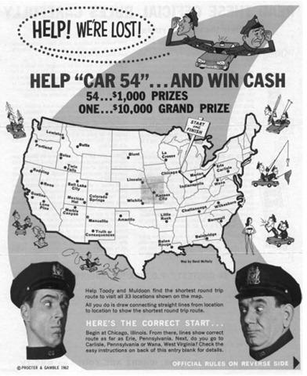
Figure 1: Advertisement for Proctor and Gamble’s Car-54 TSP contest from 1962.
B. Current Applications for the TSP
The complexities of the problem allow for varied methods in producing suitable answers with regards to a variety of real world applications. Parcel distribution systems (such as FedEx or UPS) can be modeled as large-scale TSP problems. (Sakurai, Y., et al, 2009) One also has to consider applications in the manufacturing industry. Programming a robotic arm to make multiple welds on an assembly line could be a nontraditional application of the TSP problem. (Matai, R et al. 2010) As new technologies emerge, different variations of the TSP become applicable. For example, cutting edge work is being done in replacing manned aircraft with UAVs. The goal is to minimize human risk, with those paths of a UAV being modeled as a TSP. (Sathyan et al. 2015) The TSP problem encompasses a broad area of research. A highly specific example would be regional fire specialists finding uses for UAVs in fire containment and other disaster relief (Snodgrass, 2013). These highly specific applications become relevant at the conclusion of our research as some of the hybrids show promise for advancement in small niche situations. That same hybrid might offer zero advantage in a different scenario. Ultimately application is everything when evaluating algorithms for the TSP.
C. Difficulties with the TSP: Increased Cities leads to Increased Possible Tours
How can it be known whether a given tour is the optimal tour, i.e., the tour with the shortest distance? Given a map of n cities, there are (n-1)!/2 possible tours using each city exactly once. To measure all the tours for 50,100 or even more cities would be extremely time consuming. Many mathematicians and statisticians have studied methods for reducing the number of tours that must be checked. The discovery of a good algorithm for the TSP, or a proof that no good algorithm exists, would win a prize of $1,000,000 from the Clay Mathematics Institute. (Applegate et al, 2007) In the absence of a direct method of producing the guaranteed minimum tour, algorithms have been developed to identify tours with reduced distances.
D. Algorithms for Optimizing Solutions to the TSP
- 2-Opt
This current research focuses on two specific algorithms in an attempt to identify hybrid processes that offer an improvement in distance or time. The first algorithm researched, “2-Opt,” offers a simple yet expedient solution to TSP problems. The quick computational time for this method helps to alleviate its disadvantages with regard to precision. 2-Opt is an algorithm that can be written into most programming software. 2-Opt considers one initial pair of line segments and then compares the sum of their distances to those of other pairs of line segments in the tour. When the program finds a more suitable distance, then a switch in routes is made and the program considers the next pair of line segments. The algorithm works through each pair of segments in a loop several times until the program has performed a specified number of iterations. (Sathyan et al. 2015) The code used for 2-Opt is provided in Appendix 4.
2-Opt will typically reduce the total distance for a randomly chosen route; however, different algorithms can produce improved routes with additional time used. (Sabba and Chikhi 2012)
2. Genetic Algorithms
In seeking optimal solutions for the TSP, this research also makes use of a Genetic Algorithm (GA). GAs vary in function and are used to solve a wide variety of advanced mathematical problems throughout the scientific and engineering fields. A commonality among GAs in general is their operational similarities with biological genetics. A fitness function in a computer program evaluates the quality of a population of parents, and then it identifies the most-fit variations to move on to the next generation and ultimately produce more children. As these parents are having children and are being evaluated, there is a mutation function that is semi regularly changing children in an effort to keep the population varying and healthy. Each generation consists of fit parents and children, new parents are selected for reproduction, and the process continues into the next generation. It would not be uncommon for the predetermined number of generations to be several thousand. The programmer must take special care in setting mutation and fitness functions in an effort to keep the algorithm from arriving at a local minimum. This local minimum is a non-fully optimized solution because it is unable to break free from repetitive parents in the population. (Mitchell 1996)
For the current research, given a number of specific locations for which a program is attempting to optimize tour length, the GA would randomly select a specified number of parents which are different tours using the same locations. Then much like in nature, the program would use identified parameters to generate offspring from the previously created parents. For the GA used in this research, a group of four parents are chosen at random, and then the shortest tour is chosen from the four. That shortest tour undergoes three separate mutations and these new mutated versions along with the shortest parent are carried into the next generation. In the next generation, groups of four are selected again with the shortest being mutated three ways thus creating four new options for another new generation. The program continues to cycle through many generations constantly storing the best solution until it is replaced with a newer more optimized tour. In this system, many different tours are being created and measured for their fitness as defined by tour length. GA will end by showing the most optimal tour found through a predetermined number of generations. Fig. 2 displays the process of completing one generation in GA, through this process the each generation is slightly more optimized than the previous. The code used for GA is provided in Appendix 5.

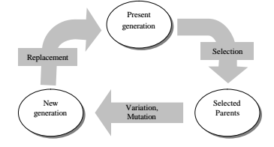
Figure 2 - Basic Cycle for Genetic Algorithm (Dianati, et al, 2002)
E. Purpose for This Research
Previous research has shown GA to produce shorter routes than 2-Opt, however, its computational time limits its effective use in some applications. Research supports an approximate ratio of 1:20 when considering computational time of 2-Opt compared with GA. (Sathyan et al. 2015) The current research seeks to use both the 2-Opt and GA algorithms in a hybrid form to make any possible improvement in run time or tour distance. Can the 2-Opt method be written into a GA code that will improve operational results? Similar work has been done in the past. Sabha and Chikhi (2012) used a hybrid GA that included a two-parent crossover operator along with a 2-Opt mutation to solve the TSP. Their data indicated that this hybrid method produced an improvement in run times and quality of solutions (length of tours). Although current research uses a different GA algorithm, it is aimed at finding further optimized results from one of the hybrid forms. These hybrids forms are outlined in the methods section.
2. GOALS AND OBJECTIVES
The primary goal of this research was to design and test hybrid 2-Opt and GA solutions for solving theTraveling Salesman Problem using Matlab®.
Objectives were as follows:
- Research methods for solving the TSP: 2-Opt and Genetic Algorithm.
- Become familiar with Matlab® software for coding and running TSP solving programs
- Adapt codes for 2-Opt and GA to create one or more hybrid approaches that combine features of both
- Test and refine hybrid approaches compared to GA and 2-Opt alone
- Communicate results
3. RESEARCH STUDY DETAILS
- Methods
The layout of this research project is closely aligned with the engineering design process (EDP). Research team members brought varying strengths to the project, which caused a learning curve with regards to understanding 2-Opt and GA processes. All of the technical research took place using Matlab®, a data analysis software used by engineers, scientists, and mathematicians. Matlab® requires programming specific code to guide the software in solving problems based on the TSP.
B. Variables Used
The nature of the TSP and operation of these optimization algorithms allow for many variables to be considered when structuring a potential optimal tour problem. Both 2-Opt and GA algorithms allow for variation in the number of cities. For this experiment, algorithms were run in groups of 50 trials (unless otherwise noted) for the following number of cities; 25, 50, and 100. Each trial began with a randomly generated map of the given number of cities. Other variables were specific to one algorithm or the other. 2-Opt allows for the algorithm to be repeated for a specified number of iterations. Current research used 10 iterations for 2-Opt for 25 and 50 cities, but used 20 iterations for 100 cities. In GA, iterations refers to how many ‘generations’ the algorithm repeats in seeking out the shortest path. Although the code that was used for GA (written by Joseph Kirk in 2009) used a set maximum number of iterations, it was decided that GA run times would be measured more accurately by how many iterations (generations) took place before the optimum path values converged. A new variable was introduced, stall, which allowed the researchers to specify how many generations would show little to no variation in optimum path values before the process would be considered complete. For this experiment, stall values of 2000 and 500 were considered. Finally, GA requires a specified value for population, the set of initial tours used to produce “children” for the next generation. Initial results of this research used a population size of 60 for all trials and algorithms. As a research extension, population size of 120 was considered for two cases.
C. Experimental Challenges and Considerations
Through laying the groundwork for running various algorithms, several potential pitfalls about using Matlab® and running the algorithm codes in general were identified. It was observed that two computers running Matlab® generated identical batches of cities using the rand command, so an approach was identified to make sure Matlab® began with new random seed values in each session. Also, two computers produced very different run times using the same code and the same exact cities. This was attributed to different CPU usage, and was addressed by running all the trials for the experiment on the same one computer. Even so, issues of CPU usage may have caused variations in the run time data. All data was generated on a Dell laptop with an i5 processor.
D. Algorithms Considered
Ultimately the team decided to compare five separate codes containing 2-Opt, GA, or both as a means to make improvement in computational time or tour length. The five different algorithms included stand-alone 2-Opt, stand-alone GA, Hybrid 1 (Front), Hybrid 2 (Middle), and Hybrid 3 (End). Both stand-alone applications were used as a way to establish a baseline for minimum tour length and time to arrive at the shortest tour.
- Hybrid 1 (Front)
The first potential hybrid option considered applying 2-Opt to one of the parents in the first generation of GA (see Fig. 3). Matlab® produced random locations for a specified number of cities. By choosing a population size of 60, the GA code called Matlab® to create 60 random tours from those cities. One of those parent tours was then run through the 2-Opt method. That 2-Opt solution was then assigned as one of the 60 parents for generation one of the GA program along with 59 other random tours. GA was then allowed to run as outlined in the literature review. This hybrid approach identifies any potential benefits to having a parent that had been previously optimized in the population.

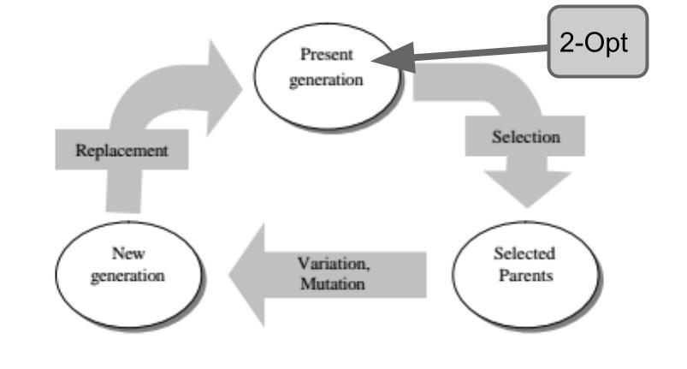
Figure 3 - Basic Cycle for Hybrid 1 (Front)

2. Hybrid 2 (Middle)
This hybrid algorithm married the 2-Opt method and GA by using 2-Opt for the mutation function, see Fig. 4. This algorithm was run in two different ways. In the first data run, GA selected a group of 5 parents, and then chose the shortest tour of the 5 to mutate in three different ways. The selected tour was also run through 2-Opt. This produced five new options for the next generation: the selected tour, its three original mutations, and the 2-Opted version. This added multiple 2-Opted solutions to each generation, but required the 2-Opt algorithm to be run multiple times in each generation. This algorithm significantly increased the program run time, which required for a Hybrid 2B (Middle) to be considered.

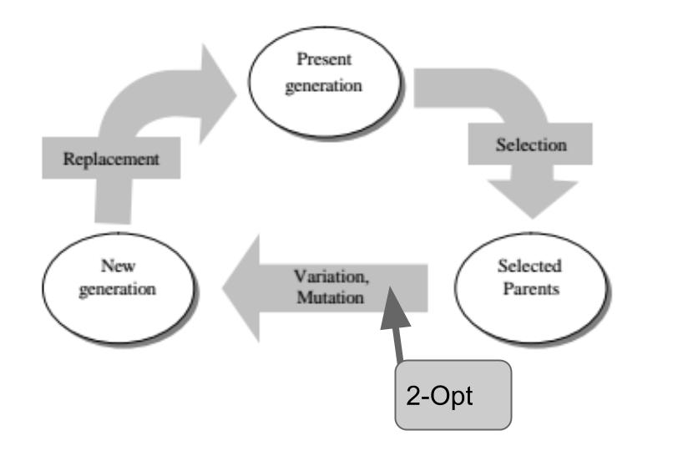
Hybrid 2 (Middle)

Figure 4 - Basic Cycle for Hybrid 2(Middle) and 2b (Middle Short)

3. Hybrid 2b (Middle short)
Initial trials showed that Hybrid 2 (Middle) needed extremely long run times, even though the number of iterations (generations) was significantly less than GA alone. Four preliminary runs of Hybrid 2 averaged 314 iterations and 97 seconds for 50 cities, while four runs of GA alone used an average of 1779 iterations. However, timed tests of GA alone for 50 cities completed in an average of 3.5 seconds. Thus, it was considered whether Hybrid 2 would perform faster if the mutation were modified. The adapted mutation ran the 2-Opt process only on a portion of the parent tour, instead of the entire parent tour. This mutation was called Hybrid 2b (Middle Short).

4. Unusual Data for Hybrid 2b (Middle short)
On the last run of data collected for 100 cities, discrepancies were found in run time for 5 of the 50 trials. Run times for these trials were more than 2 times greater than the average run time for the rest of the trials. This was attributed to the fact that the long time periods were occasionally causing the computer to fall into sleep mode. These data points were set aside and the remaining 45 values were used to calculate the average run time and tour length for 100 cities.

5.Hybrid 3 (End)
The last potential hybrid applied 2-Opt to a GA result looking for any potential improvement that could be made upon the GA’s solution. The algorithm simply applied 2-opt to a GA optimized tour, see figure 5. The team did not expect there to be any improvement in runtime as they were asking the hybrid to do additional steps past what the stand alone GA was doing. The ability of 2-Opt to improve a GA solution was the task in question.

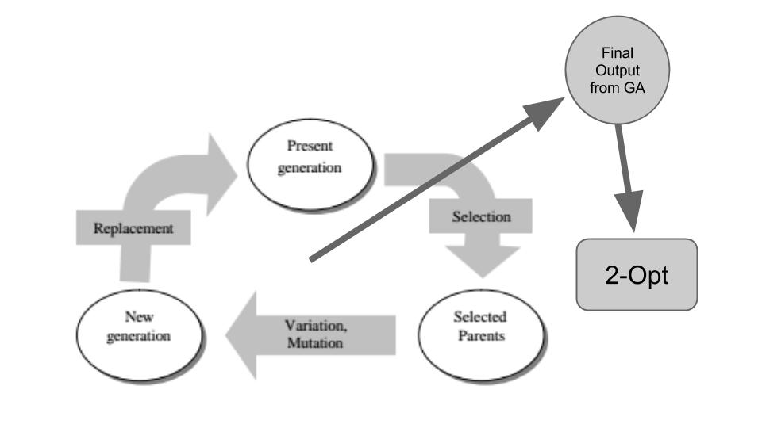
Figure 5 - Basic Cycle for Hybrid 3 (End)

6.Unusual data for Hybrid 3
The first time Hybrid 3 (End) was run on 50 batches of 100 cities, the data showed an unexplainably long average time to complete the tours. The hybrid took an average of 19.23 seconds to run each tour, while GA only needed an average of 13.515 seconds and 2-Opt needed an average of 0.69 seconds. Since Hybrid 3 simply ran 2-Opt immediately after GA, its run time was not expected to exceed the sum of the 2 original run times. Hybrid 3 (End) was run 4 more times on 50 more batches of 100 cities, and the average time for those 200 batches was found to be 9.93 seconds. This value was used in place of the 19.23 second value initially obtained.
4. RESEARCH RESULTS
The results of the research indicate a wide variety of identified considerations with which to evaluate the hybrid models used to solve the TSP. For the purpose of this study GA and 2-Opt are used as standards in the field of mathematics research as high quality algorithms that effectively find solutions for the TSP. As the hybrid algorithms are evaluated for effectiveness, they are consistently compared to GA and 2-opt, since these are assumed to be standards. The goal was to improve run time or tour distances above what was already widely available in the industry. Table 1 shows the mean values in distance and time, respectively, of 50 tours for the five tour-optimization methods tested. GA alone was tested with a stall of 500 iterations and a stall of 2000 iterations, and the best tour output was reported. These values were all normalized compared to GA. Thus, a value less than 1 implies an improvement compared to the GA, and a value greater than 1 implies an algorithm that generates a longer tour distance or time compared to GA.
Mean Distance |  |  |  | Mean Time
 | 25 Cities | 50 Cities | 100 Cities |  | 25 Cities | 50 Cities | 100 Cities
GA Alone (best) | 1 | 1 | 1 |  | 1 | 1 | 1
2-Opt Alone | 1.074 | 1.054 | 1.021 |  | 0.0168 | 0.034 | 0.087
Hybrid 1 Front | 1.024 | 1.009 | 0.995 |  | 3.870 | 1.939 | 1.224
Hybrid 2 Middle | 1.010 | 0.973 | N/A |  | 18.330 | 18.287 | N/A
Hybrid 2b Middle Short | 1.025 | 1.0197 | 1.021 |  | 6.806 | 11.039 | 38.656
Hybrid 3 End | 1.036 | 1.004 | 1.007 |  | 1.176 | 0.759 | 1.236
Table 1: Average Lengths of Tours (Distance and Time). Hybrid 2 Middle was not tested for 100 cities
because of its excessively long run time.
Fig. 6 illustrates the comparison of Hybrid 1 (Front) to the performance of GA and 2-opt. This algorithm had marginal success improving tour distance. Tour length for 100 cities showed a slight advantage toward Hybrid 1 (Front), but for the most part the algorithm made no notable improvement in distance over GA.

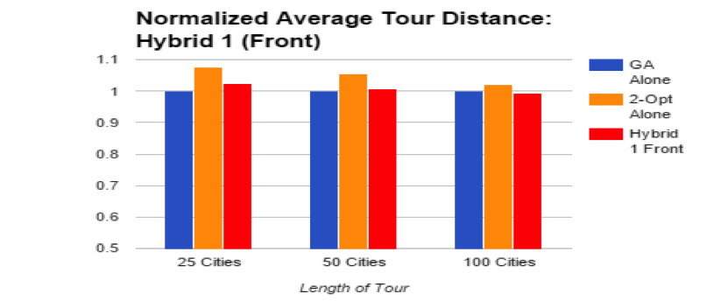
Figure 6: Average tour distance for Hybrid 1 (Front) was shorter than GA, but only for 100 cities and only by 0.5%.
Fig. 7 shows the results when two different versions of Hybrid 2 (Middle) were tested. The first variation of Hybrid 2 caused extremely long runtimes without adding any value in reducing tour length. The team opted to immediately modify the programing code to aid in reducing the algorithm run time. Results for both Hybrid 2 (Middle) and Hybrid 2b (Middle Short) are included in the data display. The most successful result was found with Hybrid 2 (Middle) for 50 cities. In 50 trials the algorithm was able to decrease the tour length suggesting its potential for future research.
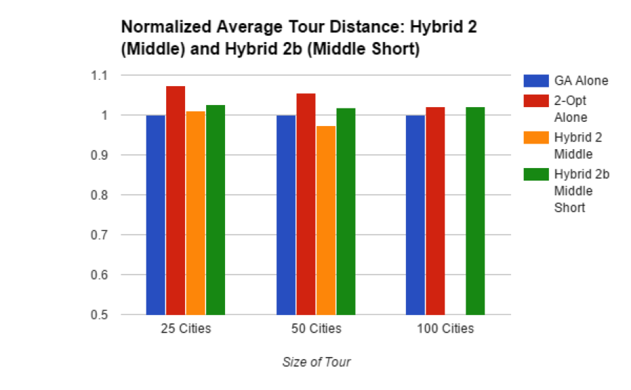
Figure 7: Average tour length for Hybrid 2 (Middle) was shorter than GA, but only for 50 cities and only by 2.7%. Hybrid 2 (Middle) was not tested for 100 cities due to very long run times for 50 cities.

Fig. 8 shows no improvement of tour length obtained by Hybrid 3 (End). In all three instances, GA alone was able to arrive at the most optimized route. The hybrid had the ability to generate comparable tours; however, comparing mean distances did not seem to indicate improvement over GA alone; median distances offered more positive evidence for Hybrid 3 (End) and will be discussed later.
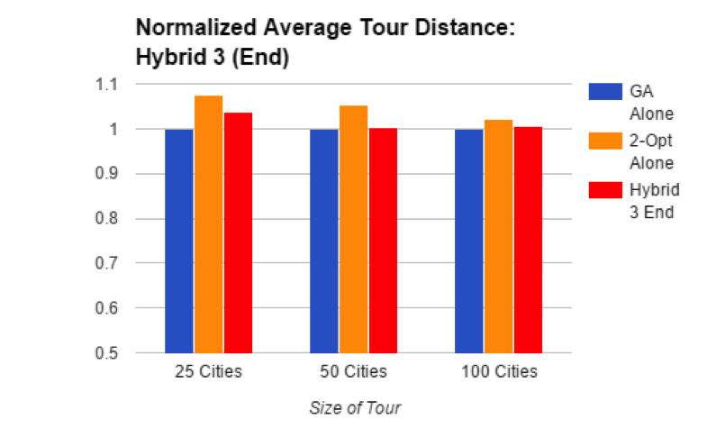
Figure 8: Hybrid 3 (End) produced average tour distances similar to or greater than the distances for GA alone.
Comparatively speaking, none of the hybrids were able to reliably outperform GA with regards to tour length or 2-Opt regarding computational time. Also, the average run times for Hybrid 2 and Hybrid 2b were not only significantly greater than the other algorithms, but also showed significant variation (standard deviations were 12.16 times greater comparing Hybrid 2b Middle with GA alone for 50 cities). This would cause concern for industry application in which a predictable run time was desirable. Two of the hybrids produced a shorter average tour distance than GA, but only in one of the three cases tested for each.
Although improvement was not identified on a consistent basis throughout the research, there were a couple of areas in the data that could be considered for further study. Hybrid 3 (End), when applied to 50 cities, was faster than GA alone but still significantly more time consuming than 2-Opt. Thus, Hybrid 3 (End) was able to achieve a comparable tour length to GA in a measurably shorter amount of time. 2-opt’s ability to arrive at an optimized tour faster is irrelevant due to its mean tour lengths being longer. There are relevant questions identified with respect to why this algorithm is able to improve run time based on the way it was constructed. Those questions are explored in the Recommendations for Future Research section.
Considering the implications of the large standard deviations of run times for Hybrid 2 (Middle) highlighted the need to compare other statistics in addition to mean values. The median and range for each set of data were reviewed using boxplots (See Fig. 9). Boxplots are an idea tool for evaluating spread of a data set since they are constructed of median and quartile values for the data. The final display gives quick reference to range broken into quarterly sections. Boxplots highlight mean-skewing outliers that have no affect upon the median. For 25 cities, the median and range for the hybrids did not indicate better performance by the hybrids compared with GA alone in distance, or 2-Opt in time. However, comparing boxplots for 50 and 100 cities showed some possible advantages to using the hybrids. Running time was analyzed for 50 cities, then 100 cities, followed by optimum distance for 100 cities.
Observing the boxplots for time to reach optimum distance using 50 cities highlighted favorable qualities for Hybrid 3 (End), see Fig 9. Although 2-Opt still used the least time to produce its result in all cases, it was noted that the median time value for Hybrid 3 (End) was less than the median time value for GA, and Hybrid 3 (End) showed a much smaller range in its results. Run times for Hybrid 2 (Middle) and Hybrid 2b (Middle Short) were noted to be significantly greater than any of the other algorithms, and are not shown to scale in Fig 9.

50 Cities - Time (in seconds) to Reach Optimum Distance
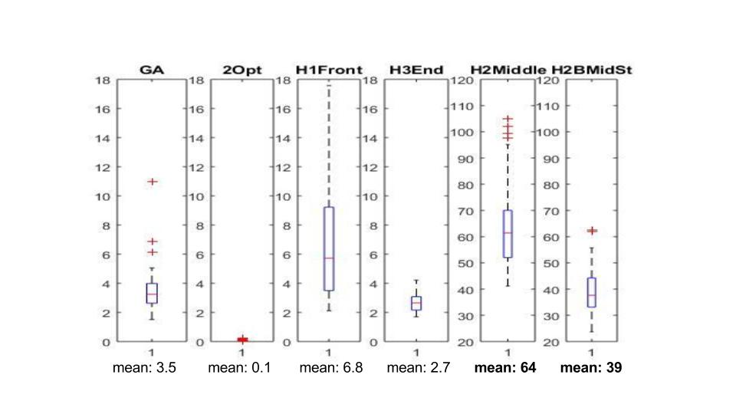
Figure 9. For 50 cities, 2-Opt used the least time to produce its result. Note the different scales for Hybrid 2 and Hybrid 2B—these hybrids took the greatest amount of time to run by far. The median time value for Hybrid 3 End was less than the median time value for GA, and Hybrid 3 End showed a much smaller range in its results. Here, time is measured in seconds. The mean is stated for comparison purposes.
In a sample of 100-city tours, GA alone produced resulting times with a lower median and a smaller range than any of the hybrids. There are a couple of data points that show the effect of how a mean tour length might be askew of the hybrids actual performance. Fig. 10 illustrates Hybrid 1 and 3’s ability to perform comparable to GA. Hybrid 2 (Middle) was not considered for time comparisons for 100 cities due to its poor results for 50-city trials.

100 Cities -- Time (in seconds) to Reach Optimum Distance
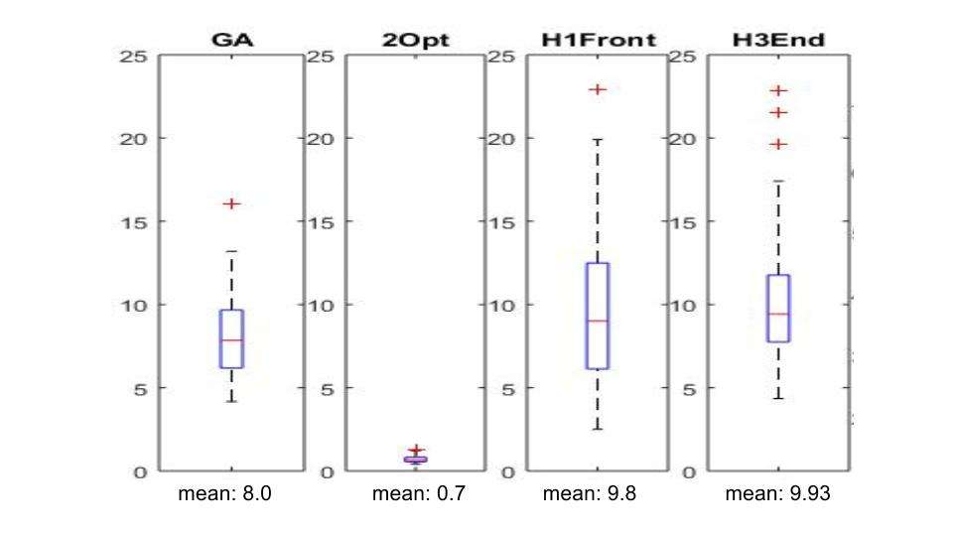
Figure 10: Boxplots. Trials for Hybrid 3 (End) used 200 maps of 100 cities; Hybrid 2b Middle (Short) used 45 maps; the other algorithms were tested using 50 maps. Here, time is measured in seconds. The mean is stated for comparison purposes.
Looking at only the mean tends to be misleading due to the pulling effect of outliers in the randomly generated tours. Comparing characteristics with these boxplots leads to previously hidden potential benefits of the hybrid models. As shown in Fig. 11, for 100 cities, the median distances for Hybrid 1 (Front) and Hybrid 3 (End) were each less than the median distance for GA alone. The high outlier value in the Hybrid 3 (End) data affected the mean, but not the median. Considering the effect of that outlier in comparison to GA makes Hybrid 3 (End) potentially more appealing for continued study and practical use.

100 Cities -- Optimum Distance for 50 Maps
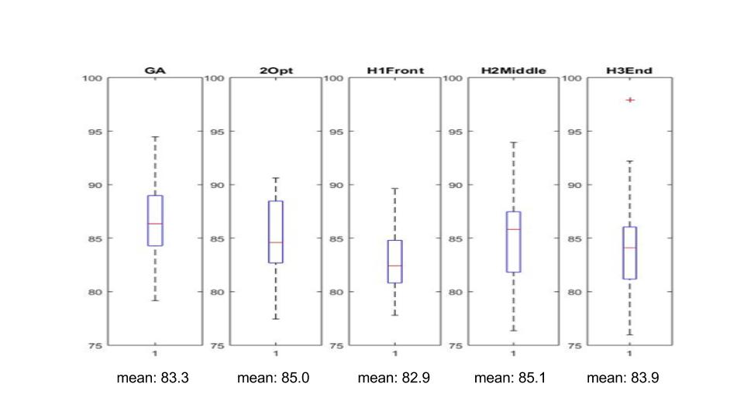
Figure 10: Boxplots show that the median distances for Hybrid 1 (Front) and Hybrid 3 (End) were less than the median distance for GA and 2-Opt alone.
A. Research Extension: Varying Population
The performance of Hybrid 1 (Front) and Hybrid 3 (End) for 100 cities warranted a closer analysis of their comparative performance toward GA. GA contains several variables that can be adjusted which will alter its ability to find solutions. The research team wanted to take a closer look at what a change in population size would do to the Hybrid versus GA comparison. Hybrid 1 (Front) had shorter average tour distances than GA for 100 cities with population size 60. Hybrid 1 (Front) and Hybrid 3 (End) both had smaller median tour distances for GA for 100 cities with population size 60. These hybrids were tested against GA alone with a population size of 120 and a stall of 2000. Since Hybrid 3 (End) also produced shorter running times than GA for 50 cities, run times were compared as well.
The results of these trials indicated that GA produced more optimum distances than either hybrid when the population size was increased to 120. (Fig. 11) The mean values for optimum distance also showed a slight advantage to GA alone (Table 2). Our research indicates that a change in variables applied to GA does not always produce a result that follows a previously observed trend. This is the case in this example as an increase in population size caused a departure from previously favorable position findings regarding GA vs Hybrids for smaller population samples. The same conclusion could be observed with respect to looking at tour distance means, which are stated in Fig. 11. GA alone still out performed either hybrid.
100 Cities, Optimum Distances for 50 Trials - Population of 120 Tours
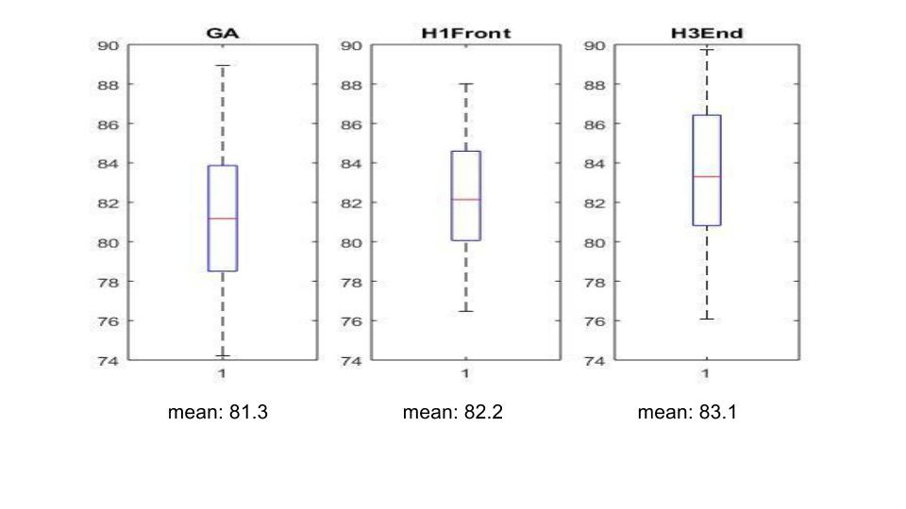
Figure 11: With a population of 120, GA alone had the shortest median tour distance compared to Hybrid 1 (Front) or Hybrid 3 (End).

The encouraging distance results for Hybrid 1 (Front) and Hybrid 3 (End) for 100 cities led the team to further investigate what advantages a change in population might offer. There were not significant results to report when looking at tour distance improvement, but Fig. 12 shows some interesting findings with relation to algorithm run time. Hybrid 1 (Front) was able to produce a shorter median running time than GA or Hybrid 3 (End). The team believes that introduction of a 2-opted parent into GA could potentially decrease the number of generations the program will run through, thus producing faster run time. The multiple variations that can be applied to GA point to future research specific to a particular application. In this small sample size, the improvement in run time for population 120 and 100 cities appears to be significantly improved.

100 Cities, Time to Reach Optimum Distance for 50 Trials - Population of 120 Tours
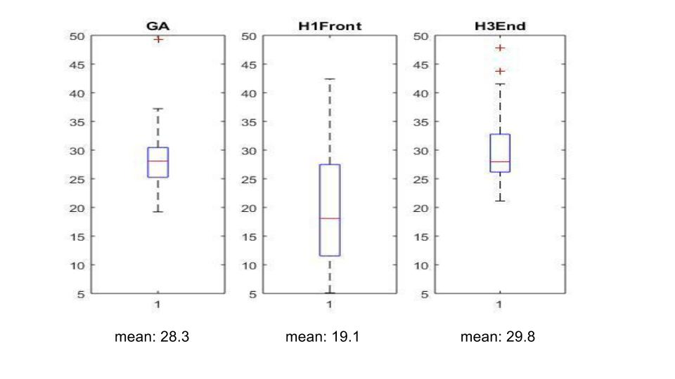
Figure 12: With a population of 120, Hybrid 1 (Front) had the shortest median running time to find the optimal path when compared with GA alone or Hybrid 3 (End).

5. RESEARCH CONCLUSIONS
This research began with a question: Can a hybrid algorithm be created to either produce shorter tours or decrease the time needed to run traditional algorithms, specifically, 2-Opt and Genetic Algorithm? The construction of an improved algorithm was of interest to allow for future use in optimization of specific applications. The team was led to draw several conclusions through this research. First and foremost, some small improvements upon GA and 2-Opt algorithms were observed in specific conditions. Though research was unsuccessful at finding all-encompassing changes that could be applied to the industry, the small improvements seen with pieces of the hybrids show promise when considering the overriding goal of the study.
The results of the trials do not indicate that any of the hybrids consistently produced shorter tours than GA alone. Average tour length for Hybrid 1 (Front) was shorter than GA, but only for 100 cities and only by 0.5%. Average tour length for Hybrid 2 (Middle) was shorter than GA, but only for 50 cities and only by 2.7%. Hybrid 2 (Middle) was not tested for 100 cities due to excessive run times. None of the hybrids came close to 2-Opt for run time. When the population was increased to 120, neither Hybrid 3 (End) nor Hybrid 1 (Front) produced a shorter median tour or a shorter mean tour than GA alone. In a circumstance where the number of cities was fixed and known, it might be advantageous to use one of the hybrids, but further testing should be done to confirm these results.

6. RECOMMENDATIONS FOR FUTURE RESEARCH
Prioritizing areas of interest in future research on solving the TSP will likely be guided by the needs of specific applications. In some situations, an optimal tour might be produced once and used over and over. In such contexts where the most optimized tour distance is necessary, research would be less concerned about methods that increase the running time. However, other applications might be motivated by a need for a quick method of producing a tour even if the distance might not be completely optimized. For example, if many tours must be generated on a regular basis, a high premium might be placed on optimizing running time for generating tours.
The data on GA alone showed that when GA was set to stall after 500 iterations, tours produced were still better than GA’s average tours for 2000 iterations for 25 and 50 cities. However, since our GA algorithm was guaranteed to produce optimal tours that did not decline in quality with successive iterations, this indicates that our sample size of 50 different city maps might not be large enough to see accurate behavior. Further research should include larger sample sizes. Using a computer with faster processing speed could make this more realistic.
The issue of the randomly generated city maps presents another approach for future research as well. For current research, random maps of cities were generated for each trial. When comparing run times for 50 cities, it was noted that Hybrid 3 (End) performed faster than GA alone, even though Hybrid 3 (End) does not change the GA process but adds the 2-Opt process to the end result and should therefore not be expected to produce shorter run times. This indicates that the randomly generated sets of maps may not always have been comparable. Future research should generate a set of random maps, and then compare the results of the different algorithms when operating on the same maps.
When a few of the Hybrids did perform favorably compared with GA, opportunities arose for future research to explore these situations. First, average tour length for Hybrid 2 (Middle) was shorter than GA for 50 cities, but Hybrid 2 (Middle) was not tested for 100 cities due to excessive run times. A subject of further research could be to test Hybrid 2 (Middle) on larger city maps on a faster computer. Second, boxplots of time for 50 cities (Figure 6) showed Hybrid 3 (End) had a smaller range of outputs than GA alone, as well as a shorter median time. A similar result was indicated when boxplots of time were reviewed for 25 cities. However, boxplots of time for 100 cities (Figure 5) showed the opposite results: Hybrid 3 (End) took longer and was less predictable. Further research could be conducted to see what conditions might cause Hybrid 3 (End) to consistently perform in a more predictable time range than GA alone.
Current research did not explore the variables for stall and population size in great depth, only considering two cases for each variable (stall of 500 and 2000; population of 60 and 120). A subject of further research might be to consider adjusting stall and population sizes could affect the tour outcome of GA. Varying population size and length of stall could allow GA alone to produce more optimum tour lengths, or produce improved results for a hybrid model.

7. CLASSROOM IMPLEMENTATION PLAN
A. Dustin Hinson’s Unit Plan
The unit “Data Collection and Analysis through Optimization” will be taught in connection to this research for the coming school year. The current curriculum map for Newport Middle School calls for this unit to be taught late in the second quarter of the school year. It falls nicely into the curriculum identified for 8th grade mathematics in the state of Kentucky. The big idea that students will be engaged with is focused on optimization in the real world. Why is it important, and how will it impact my future career/life? There is a direct relationship between optimization and the way most businesses function. This means that most students will need to understand the basic elements of optimization as adults. The challenge associated with the unit will invite students to design a t-shirt and corresponding business plan that could potentially be put into production. Students should arrive at and be able to answer the following questions. What is optimization and how does it relate to the real world? What resources do professionals use to produce the best possible product? How are mathematics applied to real world business applications when looking for “optimization”? The unit is outlined in two lessons comprised of 4 activities. The first lesson attempts to hook the students into thinking about general optimization. They will be engaged in an activity that requires producing a designed solution to an egg drop challenge, however they will be choosing building materials from a finite list of items. They will gain a sense that production cost has a huge impact on product development. In activity 2 and 3 students will continue to investigate business processes with connection to building data displays and while also starting to work to meet the challenge in Activity 4. Within the last activity is where the bulk of the challenge work will take place. Students will design a prototype t-shirt design, apply the EDP to conduct market research on the prototype, improve the design, and then build a business plan presentation to communicate their ideas to potential investors. The potential investors are middle school faculty tasked with helping me assess student work. The final business plan presentation will be a significant part of the student’s grades. The unit will also contain pre- and post-test assessments that will measure anticipated significant student growth. The unit will be presented to at least 70 students with the potential to reach even more. Optimization is a topic that can be related to most any business transaction in the modern real world and all students will be faced with making at least a few of these transactions in their lifetimes.
B. Marcia Roth’s Unit Plan
Upon returning to the classroom in the fall, Marcia Roth will implement a unit titled “UAVs and Disaster Relief.” The unit is designed for 9th grade Integrated Science students, will be implemented in November 2015, and is expected to last 3 weeks (15 class periods). Students will consider “Optimization and Disaster Relief” as the introductory Big Idea, and will identify Essential Questions such as “How can we save the most lives after a natural disaster?” The students will be challenged to design a plan using UAVs to deliver relief supplies after a natural disaster. For the second part of the challenge, students will have an opportunity to build and program robots to simulate their disaster plan. Guiding questions will include “How have natural hazards affected society?” This unit was selected to help students learn by experience about the Next Generation Science Standards for Earth and Space Science relating to Natural Hazards as well as the standards for Engineering Design. Lesson 1 will include two activities to help the students identify the Essential Question and learn about natural hazards, according to NGSS HS-ESS3-1. Lesson 2 will include the Engineering Design Process as students complete two activities designing and simulating their disaster relief plan, according to NGSS HS ETS1-4. Students will be assessed using presentation rubrics and design rubrics. 20 students are expected to be impacted by learning the academic content, gaining an appreciation for technology, and experiencing the design process.

8. ACKNOWLEDGEMENTS
Debbie Liberi, RET Director
Dr. Anant Kukreti, University of Cincinnati
RET is funded by the National Science Foundation, grant # EEC-1404766.
Genetic Algorithm Code Author: Joseph Kirk
Email: jdkirk630@gmail.com Release: 2.2 Release Date: 6/2/09

9. BIBLIOGRAPHY

Applegate,D. et al (2007). The Traveling Salesman Problem, Princeton University Press, Princeton, NJ.

Dianati M, Song I.,, and Treiber, M. An introduction to genetic algorithms and evolution strategies. Technical report, University of Waterloo, Ontario, N2L 3G1, Canada, 2002

Mitchell, M. (1996). An introduction to genetic algorithms. MIT Press, Cambridge, Mass.

Matai, R. Mittal, M, and Singh, S. (2010). Traveling Salesman Problem: an Overview of Applications, Formulations, and Solution Approaches. INTECH Open Access Publisher.

Sabha, S., and Chikhi, S. (2012). “Integrating the Best 2-opt Method to Enhance the Genetic Algorithm Execution Time in solving the Traveler Salesman Problem.” Complex Systems and Dependability (195-208) Springer Berlin Heidelberg

Sakurai, Y., Tsuruta, S., Onoyama, T.; Kubota, S. (2009). “A multi-inner-world genetic algorithm using multiple heuristics to optimize delivery schedule.” IEEE International Conference on Systems, Man and Cybernetics, 2009, San Antonio, TX, p 605-610.

Sathyan, A., Boone, N., and Cohen, K. (2015). ‘Comparison of Approximate Approaches to Solving the Travelling Salesman Problem and its Application to UAV Swarming'. International Journal of Unmanned Systems Engineering, 3(1), 1-16.

Snodgrass, P. (2013). 'Universities Aid Soaring Technology for Unmanned Aerial Vehicles'.Firehouse, 78-81.

APPENDIX I: NOMENCLATURE USED
cities = number of locations
iterations = number of cycles (2-Opt) or generations (GA)
stall = number of specified generations to show little to no variation in GA’s optimum path
population = number of tours in GA used for fitness function and reproduction
distance = length of tour
time = number of seconds needed to produce optimum tour

APPENDIX 2: TEMPLATE OF DUSTIN HINSON

Name: Dustin Hinson | Contact Info:sgthinson@yahoo.com | Date:7/9/15

Unit Number and Title: Data Collection and Analysis through Optimization

Grade Level: | 8th
Subject Area: | Math

Total Estimated Duration of Entire Unit: | 8 instructional days

Part 1: Designing the Unit
- Unit Academic Standards (Identify which standards: NGSS, ONLS and/or CCSS. Cut and paste from NGSS, ONLS and/or CCSS and be sure to include letter and/or number identifiers.):
8.SP.1 Construct and interpret scatter plots for bivariate measurement data to investigate patterns of association between two quantities. Describe patterns such as clustering, outliers, positive or negative association, linear association, and nonlinear association.
8.SP.2 Know that straight lines are widely used to model relationships between two quantitative variables. For scatter plots that suggest a linear association, informally fit a straight line, and informally assess the model fit by judging the closeness of the data points to the line.
8.SP.3 Use the equation of a linear model to solve problems in the context of bivariate measurement data, interpreting the slope and intercept. (For example, in a linear model for a biology experiment, interpret a slope of 1.5 cm/hr as meaning that an additional hour of sunlight each day is associated with an additional 1.5 cm in mature plant height.)
8.SP.4 Understand that patterns of association can also be seen in bivariate categorical data by displaying frequencies and relative frequencies in a two-way table. Construct and interpret a two-way table summarizing data on two categorical variables collected from the same subjects. Use relative frequencies calculated for rows or columns to describe possible association between the two variables.
(For example, collect data from students in your class on whether or not they have a curfew on school nights and whether or not they have assigned chores at home. Is there evidence that those who have a curfew also tend to have chores?)

- Unit Summary
The Big Idea (including global relevance):
The unit focus is optimization, which is applying mathematics to find the best possible solution to a problem. The instruction will be taught under the umbrella of a Data Analysis unit. Building scatter plots and comparing data for the purpose for analyzing relationships with in two different data sets is a large part of 8th grade mathematics. The students will be learning and working through an understanding of basic business practices. At the conclusion of the unit, the students will need to understand that basic optimization is essential in all business formats and that mathematics drive most business decisions. Their ability to solve math problems will be extremely important to them in their careers.

The (anticipated) Essential Questions: List 3 or more questions your students are likely to generate on their own. (Highlight in yellow the one selected to define the Challenge):

What is optimization and how does it relate to the real world?
What resources do professionals use to produce the best possible product?
How do you know when an idea or object is “optimized”?
How are mathematics applied to real world business applications when looking for “optimization”?

- Unit Context – Check all that apply.
Justification for Selection of Content:
☐ Students previously scored poorly on standardized tests, end-of term test or any other test given in the school or district on this content.
☐ Misconceptions regarding this content are prevalent.
☒ Content is suited well for teaching via CBL and EDP pedagogies.
☐ The selected content follows the pacing guide for when this content is scheduled to be taught during the school year. (Unit 1 covers atomic structure because it is taught in October when I should be conducting my first unit.)
☒ Other reason(s) _____________________________________________________________
_____________________________________________________________________________

The Hook: Protect an egg challenge.
Students will be given a predetermined amount of money that they will then use to buy materials to construct their object that will protect a golf ball size object. They will later find out that the object is an egg. The students will begin by building a basic understand of an optimization problem. Often in life and business materials are not infinitely accessible, and the most successful businesses find ways to maximize profits by using materials in an optimum way. The teacher will use the challenge as a way to foster a classroom discussion about general optimization.

The Challenge and Constraints:
The challenge will call students to design a t-shirt that can be sold as the official 8th grade t-shirt. The challenge will be to collect data that guides the design process toward an end product that is both cost efficient and appealing to the students. A winning design will be printed at the high school print shop and sold at the middle school as spirit wear.

☐ Product or ☒ Process (Check one)

Description of Challenge (Either Product or Process is clearly explained below): | List the Constraints Applied
In groups of 3 to 4 students will be challenged with designing an 8th grade school spirit t-shirt. They will conduct research into the desires of the consumer base (fellow students), design logos, and pick color schemes that should be appealing to their peers. They will then assemble a business plan to present to a board of potential investors. The plan will be heavily based in their research of interest and spending habits of the consumer base. The best business plan will then be moved into production as the 8th grade t-shirt. | *Time  *Limitations of printing shop at the high school (To be determined, my district would require me to use the printing program at the high school so those students get practical experience as well.)  *End product cost. (The business plan evaluators will be looking for a design that students can actually afford.  *The t-shirt cannot cost more than 12 dollars per shirt.  *All design features must be supported by market research.  *T-shirt must be acceptable as school spirit wear, which will allow it to be worn as meeting dress code. The teacher will provide them with a dress code passage pulled directly from our student conduct handbook.  *Students must model a linear relationship to justify their choice of t-shirt material. Specifically the cost of cotton verses a synthetic material. The linear model should show the approximate point in which students are no longer willing to pay for a synthetic material. Line graph should work nicely for this.

Anticipated Guiding Questions (that apply to the Challenge and may change with student input.):
Can we develop the perfect logo that kids will want on their 8th grade t-shirt?
At what point does the cost of graphics/colors become too expensive with regards to the constraints?
Is there a way to make money off of t-shirt sales or should they be sold “at cost”?
Does it matter which material we choose to use for the t-shirts?
How do we generate data that will support our design in a mathematical way?
What is the best way to display the data we find?

4. EDP: Use the diagram below to help you complete this section.
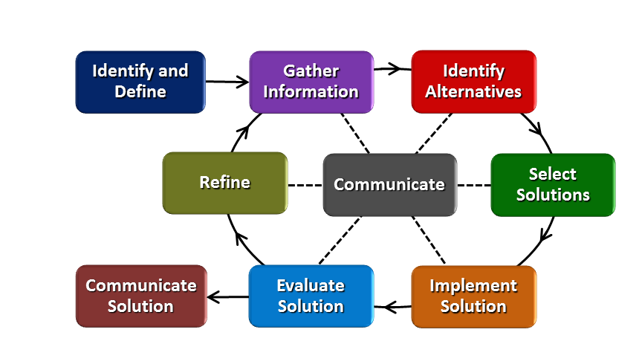
How will students test or implement the solution? What is the evidence that the solution worked? Describe how the iterative process from the EDP applies to your Challenge.
The student groups will present their business plan to a panel of judges that will pick the best design/ business model. The most “optimized” business plan that shows evidence of the design process will then be put into production. The focus of the plan should be data collection and the design of the students supporting data. Students will have many options available to them in terms of data collection. As a group the students will make decisions on what they need to know about their potential customer base. They will develop market research and implement it among their peers. Then decide if it accurately describes what students are interested in and choose the appropriate display to support their business plan. The rubric will clearly describe the necessary connection between the supporting data and business plan.
How will students present or defend the solution? Describe if any formal training or resource guides will be provided to the students for best practices (e.g., poster, flyer, video, advertisement, etc.) used to present work.
The teacher should offer student choice in data presentation and plan articulation with regards to the business plan. Every student has an Ipad so they have many options with which to share data and support their designs. Students will be required to use numbers for data collection which is the apple version of excel. Every student has access to this program. Students will be presenting a business plan to a panel of judges. The teacher should be highly engaged with the groups as they are working on their plan. During this time the teacher will be encouraging students to use proper media types that will illustrate their plan.
(See business plan rubric in materials.)
What academic content is being taught through this Challenge?
Data Analysis/Comparison- Students will be analyzing and comparing a vast variety of data types and displays. Reading most types of displays will be a review of previous knowledge.
Scatter plot construction- Scatter plots will be new material that the 8th grade students will be exposed to. Time and focus will be spent on constructing and analyzing various plots.

Using the diagram above, identify any places in the EDP where assessments should take place, as it applies to your Challenge. Describe below what kinds of assessment are most appropriate.

What EDP Processes are ideal for conducting an Assessment? (List ones that apply.) | List the type of Assessment (Rubric, Diagram, Checklist, Model, Q/A etc.) Check box to indicate whether it is formative or summative.
Gather Information  Identify Alternatives  Select Solution  Evaluate/Communicate Solution | Checklist ☒ formative ☐ summative  Brainstorming activity ☒ formative ☐ summative  Rubric with key components ☒ formative ☐ summative  Rubric and Presentation ☐ formative ☒ summative
Gather information, Identify Alternatives, and Select a Solution.  Evaluate/Communicate Solution | At all three of these phases of the EDP the assessment should be formative. Unknowing to the students, It will be the responsibility of the teacher to give enough feedback during these parts to encourage students and help them construct an end product that is consistent with the goals/objectives of the unit. Teacher might need to help generate ideas of appropriate media types students could use in presentation.  This assessment will be summative and significant to student’s grades. The judging panel will be given a rubric in which to use for business plan scoring purposes.
Check below which characteristic(s) of this Challenge will be incorporated in its implantation using EDP. (Check all that apply.)
☒ Has clear constraints that limit the solutions
☒ Will produce than one possible solution that works
☒ Includes the ability to refine or optimize solutions
☒ Assesses science or math content
☒ Includes Math applications
☒ Involves use of graphs
☒ Requires analysis of data
☒ Includes student led communication of findings

5. ACS (Real world applications; career connections; societal impact):
Place an X on the continuum to indicate where this Challenge belongs in the context of real world applications:
Abstract or Loosely Applies to the Real World | |--------------------------------------|-----------------------------------x----| | Strongly Applies to the Real World

Provide a brief rationale for where you placed the X:_The students are looking at a problem that exist in most businesses. Find the best possible product while balancing demand and cost efficiency. I believe this to be a basic strategy for every business. On one level or another, all of my students will be expected to do this at some point during their working life.

What activities in this Unit apply to real world context?
The students are actually going to send the winning t-shirt design to a manufacture for production. They will be able to purchase a wear the shirt as spirit wear for school. The t-shirt will be pick by presenting the best business plan.

Place an X on the continuum to indicate where this Challenge belongs in the context of societal impact:
Shows Little or No Societal Impact | |-------------------------------------|-------------x---------------------------| | Strongly Shows Societal Impact

Provide a brief rationale for where you placed the X: I believe the project to have significant social impact do to the fact that many students will be wearing the shirt on the regular basis. The product does not contain the element of greatly improving the world around us. Students are not trying to make the world a better place, however they are developing an ethical business model that will produce a desired outcome.

What activities in this Unit apply to societal impact?
The design of the shirt will impact school spirit and hopefully encourage students to take pride in their community. The students will also touch on ethical business practices throughout the unit that will have a great impact upon them as adults entering the business world.

Careers: What careers will you introduce (and how) to the students that are related to the Challenge? (Examples: career research assignment, guest speakers, fieldtrips, Skype with a professional, etc.)
All business professions
Engineering mainly of the mechanical and structural types.

6. Misconceptions:
Students are likely to come to school with misgivings about what it takes to produce a product that people actually want to buy. The research and development that most businesses apply to everyday products is probably not understood by most of my students.
I expect students to struggle with developing sufficient data to support their design. I will be encouraging them through brainstorming activities and modeling effective data analysis tools during instruction after the hook.

7. Unit Lessons and Activities: (Provide a tentative timeline with a breakdown for Lessons 1 and 2. Provide the Lesson #’s and Activity #’s for when the Challenge Based Learning (CBL) and Engineering Design Process (EDP) are embedded in the unit.)
CBL: L1A1,L2A2
EDP L1A1,L1A2,L2A3,L2A4
Lesson 1- This three-day lesson will be used to get the students started to think about optimization. The students will participate in the hook, which is part optimization problem, brainstorm ideas for what we could “optimize”, and start to work on building appropriate data displays.
Lesson 2- In this five day lesson students will finish learning about data displays and participate in the challenge of building a t-shirt. The unit culminates with the students presenting a well-supported business plan encompassing many CBL and EDP aspects that have been spiraled in throughout the unit.

L1A1- The big “why” in data collection. (One day) This is a one day activity designed to introduce the idea of optimization. The entire EDP is part of this lesson, and will be referred to during the activity introduction as well as throughout the student working time. The teacher will be roaming the room providing feedback with reference to the EDP process. At the conclusion of this small challenge, students will be engaged in an introduction to optimization. Could they have protected the egg with infinite materials? Answer should be yes, however cost will be introduced into the conversation. Does it make sense to use 4 dollars of paper to protect a 12 cent egg? CBL begins in this lesson with the hook and is set up in a way that it can be carried throughout the unit. Students will arrive at their own challenge of designing an 8th grade t-shirt.
L1A2- The big “why” in data collection. (Two days) This is a two day activity where a significant portion of the content needed to complete the challenge will be taught. The students will spend these days working through data analysis type questions. I will be modeling the skills needed to accurately display data from two way tables. The EDP will be introduced here and spiraled throughout the following activities. Students will be working through complex word problems that require them to collectively work through the EDP on a small scale. This should help them implement the EDP on their overarching challenge project.
L2A3- Devising an Optimized Business Plan (Two days). This is a two day activity where student will continue to work on data analysis and construction. I will introduce the concept of scatter plots to the students and they will be building scatter plots of their own.
L2A4- Devising an Optimized Business Plan (Three days). This is a three-day activity, however the teacher could potentially extend the student work time should the student’s effort warrant it. Students will have already been in groups and started their work on designing a business plan and t-shirts. I am listing this as a three day activity do to students needing a specific block of work time to pull all of their thoughts/ideas together, administer surveys to the class, and prepare/present their presentation.
Students will be given small chunks of time to brainstorm and prepare surveys throughout the second and third activities of the unit. The EDP will play a role in these small allotments of time. The formative assessment will take place during these time periods, and the teacher will guiding students toward a solid final product.

8. Additional Resources:
Materials for egg drop
Data analysis word problems
Materials for t-shirt design
Formal list of constraints from high school printing department.
Pricing information from school printing department.

9. Pre-Unit and Post-Unit Assessment Instruments:

10. Poster (Link here.) | 11. Video (Link here.)

If you are a science teacher, check the boxes below that apply:
Next Generation Science Standards (NGSS)
Science and Engineering Practices (Check all that apply) | Crosscutting Concepts (Check all that apply)
☐ Asking questions (for science) and defining problems (for engineering) | ☐ Patterns
☐ Developing and using models | ☐ Cause and effect
☐ Planning and carrying out investigations | ☐ Scale, proportion, and quantity
☐ Analyzing and interpreting data | ☐ Systems and system models
☐ Using mathematics and computational thinking | ☐ Energy and matter: Flows, cycles, and conservation
☐ Constructing explanations (for science) and designing solutions (for engineering) | ☐ Structure and function.
☐ Engaging in argument from evidence | ☐ Stability and change.
☐ Obtaining, evaluating, and communicating information

If you are a science teacher, check the boxes below that apply:
Ohio’s New Learning Standards for Science (ONLS)
Expectations for Learning - Cognitive Demands (Check all that apply)
☐ Designing Technological/Engineering Solutions Using Science concepts (T)
☐ Demonstrating Science Knowledge (D)
☐ Interpreting and Communicating Science Concepts (C)
☐ Recalling Accurate Science (R)

If you are a math teacher, check the boxes below that apply:
Common Core State Standards -- Mathematics (CCSS)
Standards for Mathematical Practice (Check all that apply)
☒ Make sense of problems and persevere in solving them | ☒ Use appropriate tools strategically
☒ Reason abstractly and quantitatively | ☒ Attend to precision
☒ Construct viable arguments and critique the reasoning of others | ☐ Look for and make use of structure
☐ Model with mathematics | ☐ Look for and express regularity in repeated reasoning

Part 2: Post Implementation- Reflection on the Unit
Results: Evidence of Growth in Student Learning - After teaching the Unit, present the evidence below that growth in learning was measured through one the instruments identified above. Show results of assessment data that prove growth in learning occurred.

Please include:
- Any documents used to collect and organize post unit evaluation data. (charts, graphs and /or tables etc.)
- An analysis of data used to measure growth in student learning providing evidence that student learning occurred. (Sentence or paragraph form.)
- Other forms of assessment that demonstrate evidence of learning.
- Anecdotal information from student feedback.

Reflection: Reflect upon the successes and shortcomings of the unit. Refer to the questions posed on the Unit Template Instruction sheet. Describe how the actual Engineering Design Process was actually used in the implementation of the Unit.

Name: Dustin Hinson | Contact Info:sgthinson@yahoo.com | Date:

Lesson Title : The big “why” in data collection. | Unit #:1 | Lesson #:1 | Activity #:1
Activity Title: Introduction to Optimization

Estimated Lesson Duration: | 3 days
Estimated Activity Duration: | 1 day

Setting: | Middle school classroom, 8th grade students in an urban setting.

Activity Objectives: The students can as a group evaluate the cost effectiveness of basic items needed to complete a task. (Students will spend the vast majority of the class time working through the hook challenge. They will be choosing the best items to purchase toward meeting the goal of the task. Their decisions will be made informally as they will need materials for starting the task. Their success or failure will be used in the concluding discussion to bring in suggestions for a challenge.

Activity Guiding Questions:
Why do I need to consider cost when working on a design project?
How do I know which items are the most important to purchase?
How do I work with in a group to meet a common task on time?
What costs do businesses need to consider when establishing a price for a newly developed product?

Next Generation Science Standards (NGSS)
Science and Engineering Practices (Check all that apply) | Crosscutting Concepts (Check all that apply)
☐ Asking questions (for science) and defining problems (for engineering) | ☐ Patterns
☒ Developing and using models | ☒ Cause and effect
☒ Planning and carrying out investigations | ☒ Scale, proportion, and quantity
☐ Analyzing and interpreting data | ☒ Systems and system models
☒ Using mathematics and computational thinking | ☐ Energy and matter: Flows, cycles, and conservation
☒ Constructing explanations (for science) and designing solutions (for engineering) | ☒ Structure and function.
☒ Engaging in argument from evidence | ☐ Stability and change.
☐ Obtaining, evaluating, and communicating information

Ohio’s New Learning Standards for Science (ONLS)
Expectations for Learning - Cognitive Demands (Check all that apply)
☒ Designing Technological/Engineering Solutions Using Science concepts (T)
☐ Demonstrating Science Knowledge (D)
☐ Interpreting and Communicating Science Concepts (C)
☐ Recalling Accurate Science (R)

Common Core State Standards -- Mathematics (CCSS)
Standards for Mathematical Practice (Check all that apply)
☒ Make sense of problems and persevere in solving them | ☒ Use appropriate tools strategically
☒ Reason abstractly and quantitatively | ☐ Attend to precision
☒ Construct viable arguments and critique the reasoning of others | ☐ Look for and make use of structure
☐ Model with mathematics | ☐ Look for and express regularity in repeated reasoning

Unit Academic Standards (NGSS, ONLS and/or CCSS):
8.SP.3 Use the equation of a linear model to solve problems in the context of bivariate measurement data, interpreting the slope and intercept. (For example, in a linear model for a biology experiment, interpret a slope of 1.5 cm/hr as meaning that an additional hour of sunlight each day is associated with an additional 1.5 cm in mature plant height.)

Materials: (Link Handouts, Power Points, Resources, Websites, Supplies)
1. Physical materials for task: eggs, golf balls, paper, tape, paper clips, straws,
2. Handout with task instructions
3. Tube with mounting bracket to ensure consistency drop.
4.Group work assignment sheet
5. Linear equations comparison homework.

Teacher Advance Preparation:
Materials for the hook activity must be pulled. Students need to be given some type of money to use as currency to purchase the needed items for the egg drop challenge. The teacher needs to have a reasonable plan for selling items to students while walking through the room monitoring group progress.
Egg drop tube built and attached to a drop location.

Activity Procedures:
- Unit introduction
- Find out what students know about optimization. What is the overriding goal of any business that provides a product or service? How does this relate to them?
- Develop Essential Questions for the Unit.
- Hook Activity
- Assign the students to groups based on student ability. Group’s members should vary in abilities and strengths.
- Give an overview of the task at hand. What is the goal for each group? Define the parameters and the constraints of the activity. Pass out handout.
- Outline any special procedures for the day to include; how much money each group gets and how do they go about purchasing items for construction of their protection device.
- Hand out needed assignments. Students will need to prove that they have engaged in a group discussion focused on a plan to successfully fulfill the task. The assignment sheet ask students to describe their role in what would become the final outcome.
- Assuming it appears that all groups reasonably understand the task, begin to sell items to groups. Keep a watchful eye on materials used to ensure the fairness of the challenge.
- Student work time. Quickly sell the items to the groups and give them time to work on construction of their device. Monitor student materials to ensure that they are only using items purchased from the teacher. The materials constraint is important to the learning of the idea “optimization”.
- Formatively evaluate each group’s device. Document their final device with a photo.
- Test each group’s ability to protect an egg sized object.
- After all groups have gotten a chance to drop their egg hold a debriefing session. What strategies seemed to work well and which did not? Where the items appropriately priced? Which items seemed to be the most valuable? The groups that had a cracked egg, how confident are they that give new materials and time them could meet the task? Would it be easy to complete the task given infinite materials? Did planning and communication play and important role in being successful?
- Introduce selling salt app. http://forio.com/simulation/mit-sloan-salt/index.htm
Use this activity to further engage the students in discussion of general optimization. It potentially could be used as additional support for helping the students develop ideas for the challenge. Introduce the big idea optimization. (Pose these to students) Can you put optimization in your own words? What if we were to sell something? What are the things you have to think about to stay in business?
- Ask students for their input on the unit challenge. What could we “optimize”? Students will be asked if we were to pursue a business venture as a class what would you want to sell? (Exit slip) What are some of the most important things you use on the daily bases? They will be given the opportunity to generate ideas and submit them to the teacher. I will then use their input to generate the challenge and introduce it on the following days instruction.
- Assign comparing linear equation problem for homework.

Formative Assessments: Link the items in the Activities that will be used as formative assessments.
The assessment “Gather information” will be incorporated in to activity and used in a formative way. Students will do some self-assessment at the conclusion of the activity. The document will ask them to describe their part in the activity, and also ask about their new found understand of optimization and how it will apply to us as a class. (The challenge)

Summative Assessments: These are optional; there may be summative assessments at the end of a set of Activities or only at the end of the entire Unit.
None for this activity.

Differentiation: Describe how you modified parts of the Lesson to support the needs of different learners.
Refer to Activity Template for details.
Most of the differentiation is addressed with in the structure of the groups. Each group should have all different types of learners with varying abilities. Responsibilities assigned with in the groups all for all students to apply value toward the completion of the assignment.

Reflection: Reflect upon the successes and shortcomings of the lesson.

Name: Dustin Hinson | Contact Info: sgthinson@yahoo.com | Date:

Lesson Title : The big “why” in data collection. | Unit #:1 | Lesson #:1 | Activity #:2
Activity Title: Comparing cost factors in a business model

Estimated Lesson Duration: | 3 days
Estimated Activity Duration: | 2 days

Setting: | Middle school classroom, 8th grade students in an urban setting.

Activity Objectives: The students can evaluate cost in terms of linear equations to make educated financial decisions. “What is the best deal?”

Activity Guiding Questions:
How do businesses decide what to charge their customers?
Does the amount of goods purchased factor into the best deal?

Next Generation Science Standards (NGSS)
Science and Engineering Practices (Check all that apply) | Crosscutting Concepts (Check all that apply)
☐ Asking questions (for science) and defining problems (for engineering) | ☒ Patterns
☐ Developing and using models | ☐ Cause and effect
☐ Planning and carrying out investigations | ☐ Scale, proportion, and quantity
☒ Analyzing and interpreting data | ☐ Systems and system models
☒ Using mathematics and computational thinking | ☐ Energy and matter: Flows, cycles, and conservation
☐ Constructing explanations (for science) and designing solutions (for engineering) | ☒ Structure and function.
☐ Engaging in argument from evidence | ☐ Stability and change.
☐ Obtaining, evaluating, and communicating information

Ohio’s New Learning Standards for Science (ONLS)
Expectations for Learning - Cognitive Demands (Check all that apply)
☐ Designing Technological/Engineering Solutions Using Science concepts (T)
☐ Demonstrating Science Knowledge (D)
☐ Interpreting and Communicating Science Concepts (C)
☐ Recalling Accurate Science (R)

Common Core State Standards -- Mathematics (CCSS)
Standards for Mathematical Practice (Check all that apply)
☒ Make sense of problems and persevere in solving them | ☒ Use appropriate tools strategically
☒ Reason abstractly and quantitatively | ☒ Attend to precision
☐ Construct viable arguments and critique the reasoning of others | ☒ Look for and make use of structure
☒ Model with mathematics | ☒ Look for and express regularity in repeated reasoning

Unit Academic Standards (NGSS, ONLS and/or CCSS):
8.SP.3 Use the equation of a linear model to solve problems in the context of bivariate measurement data, interpreting the slope and intercept. (For example, in a linear model for a biology experiment, interpret a slope of 1.5 cm/hr as meaning that an additional hour of sunlight each day is associated with an additional 1.5 cm in mature plant height.)

8.SP.4 Understand that patterns of association can also be seen in bivariate categorical data by displaying frequencies and relative frequencies in a two-way table. Construct and interpret a two-way table summarizing data on two categorical variables collected from the same subjects. Use relative frequencies calculated for rows or columns to describe possible association between the two variables.
(For example, collect data from students in your class on whether or not they have a curfew on school nights and whether or not they have assigned chores at home. Is there evidence that those who have a curfew also tend to have chores?)

Materials: (Link Handouts, Power Points, Resources, Websites, Supplies)
Word problems assignment
Brainstorming activity sheet
Graph paper for bar graph

Teacher Advance Preparation: It would be a good idea to have worked through the word problems and developed a plan for displaying the

Activity Procedures:
- Review homework and debrief concepts of previous day.
- Check for misunderstandings in the homework. Give students access to key so they can evaluate their own level of understanding.
- Review topic and concepts from previous day’s instruction. What is optimization and why is it important? What did they learn from yesterday’s activity? Discuss guiding questions.
- Introduce today activity. Look at how to create a two way table. When would this be useful? Does this relate to yesterday? How? Is there a better way to display this data so that it is user friendly?
- Work through several practical word problems that require us to collect or organized data in a manner that will assist us in finding a viable solution. Construct two way tables. Look at other means of data collection. Problems supplied by teacher.
- As a review turn a sample problem from the previous set in a bar graph. Students should be familiar with this, and it just needs to be a sketch. It will be important to not use more than 10 minutes of class time for this.
- At this point in class introduce the challenge. Look back through the essential questions and read student comments from the optimization discussion from the previous day.
- They will be using the same groups from the hook activity.
- Show them the rubric and briefly describe the challenge.
- Give them 5 minutes to complete a brainstorming activity. Handout that ask each group member to record “what would you want in a school spirit shirt?” Group work formative assessment.
- Relate the day’s instruction to how it will help them implement a solid business plan. Show some sample business plans.
- Classwork assignment with the remaining time. Students continue to work with two-way tables, both analyzing and constructing.

Formative Assessments: Link the items in the Activities that will be used as formative assessments.
Group work brainstorming idea sheet. Every student will be held accountable to contribute at least one idea to the sheet and the group. The sole purpose is to just general ideas.

Summative Assessments: These are optional; there may be summative assessments at the end of a set of Activities or only at the end of the entire Unit. None

Differentiation: Describe how you modified parts of the Lesson to support the needs of different learners.
Refer to Activity Template for details.
The student will be working in their assigned groups for a large portion of this unit. The groups should be designed in such a way as to allow the students to work for several days with the same individuals. This will help them build ideas and trust in one another throughout the lessons.
Students needing extra guidance will be able to rely upon group mates or teachers for assistance. The classwork can be modified in a way that will encourage some students to be more independent. Graphs and tables can be started in a way that will help struggling students organize their work.

Reflection: Reflect upon the successes and shortcomings of the lesson.

Name: Dustin Hinson | Contact Info:sgthinson@yahoo.com | Date:

Lesson Title : Devising an Optimized Business Plan | Unit #:1 | Lesson #:2 | Activity #:3
Activity Title: Supporting a plan with data.

Estimated Lesson Duration: | 5 days
Estimated Activity Duration: | 2 days

Setting: | Middle school classroom, 8th grade students in an urban setting.

Activity Objectives:
Students can collect appropriate data and organize it in a user friendly way.
Students can communicate the results of data collection to their peers and evaluators.

Activity Guiding Questions:
What is the real world relevance for data collection?
How do I select the appropriate data display?
Why do I need to create data displays to prove a point?
How could data be considered misleading?

Next Generation Science Standards (NGSS)
Science and Engineering Practices (Check all that apply) | Crosscutting Concepts (Check all that apply)
☐ Asking questions (for science) and defining problems (for engineering) | ☒ Patterns
☐ Developing and using models | ☐ Cause and effect
☐ Planning and carrying out investigations | ☒ Scale, proportion, and quantity
☒ Analyzing and interpreting data | ☐ Systems and system models
☒ Using mathematics and computational thinking | ☐ Energy and matter: Flows, cycles, and conservation
☒ Constructing explanations (for science) and designing solutions (for engineering) | ☐ Structure and function.
☒ Engaging in argument from evidence | ☐ Stability and change.
☐ Obtaining, evaluating, and communicating information

Ohio’s New Learning Standards for Science (ONLS)
Expectations for Learning - Cognitive Demands (Check all that apply)
☐ Designing Technological/Engineering Solutions Using Science concepts (T)
☐ Demonstrating Science Knowledge (D)
☐ Interpreting and Communicating Science Concepts (C)
☐ Recalling Accurate Science (R)

Common Core State Standards -- Mathematics (CCSS)
Standards for Mathematical Practice (Check all that apply)
☒ Make sense of problems and persevere in solving them | ☒ Use appropriate tools strategically
☒ Reason abstractly and quantitatively | ☒ Attend to precision
☒ Construct viable arguments and critique the reasoning of others | ☒ Look for and make use of structure
☒ Model with mathematics | ☒ Look for and express regularity in repeated reasoning

Unit Academic Standards (NGSS, ONLS and/or CCSS):
8.SP.1 Construct and interpret scatter plots for bivariate measurement data to investigate patterns of association between two quantities. Describe patterns such as clustering, outliers, positive or negative association, linear association, and nonlinear association.

8.SP.2 Know that straight lines are widely used to model relationships between two quantitative variables. For scatter plots that suggest a linear association, informally fit a straight line, and informally assess the model fit by judging the closeness of the data points to the line.

Materials: (Link Handouts, Power Points, Resources, Websites, Supplies)

Teacher Advance Preparation:

Activity Procedures:
- Review previous day’s instruction.
- Formatively evaluate the previous day’s assignment.
- Review learning from previous day.
- Constructing a scatter plot.
- Instruction of how to build a scatter plot. Identify its advantages with in data collection. How could it be applicable for us to use on our projects.
- Height v/s Wing Span activity. Students construct all of the needed pieces to build an accurate scatter plot. The various parts of a scatter plot can be identified with in the assignment.
- Students use data to build their own scatter plots.
- Students use scatter plots to summarize information and make arguments toward a solution of a problem.
- Students brainstorm about possible scatter plots that could be formed in their groups as a way to make sense of the data they are collecting with regards to their projects.
- They will be given a partial rubric which outlines the parameters of the future challenge. This way they can come up with a potential plan for data collection.
- They will be given work time in their challenge groups to develop a rough prototype.

Formative Assessments: Link the items in the Activities that will be used as formative assessments.
Solution selection – rubric specific to choosing and implementing the correct data display.

Summative Assessments: These are optional; there may be summative assessments at the end of a set of Activities or only at the end of the entire Unit.
None

Differentiation: Describe how you modified parts of the Lesson to support the needs of different learners.
Refer to Activity Template for details.

Reflection: Reflect upon the successes and shortcomings of the lesson.

Name: Dustin Hinson | Contact Info: sgthinson@yahoo.com | Date:

Lesson Title : Devising an Optimized Business Plan | Unit #:1 | Lesson #:2 | Activity #:4
Activity Title: Building the best t-shirt design and business plan.

Estimated Lesson Duration: | 5 days
Estimated Activity Duration: | 5 days (Challenge parts are worked on throughout the Unit.)

Setting: | Middle school classroom, 8th grade students in an urban setting.

Activity Objectives:
The students will design a data collection process that will assist them in communicating a business plan for an 8th grade t-shirt.

Activity Guiding Questions:
What factors play into purchasing a t-shirt?
At what price point do students loose interest in buying a shirt?
What logos are the most popular and generate the most interest?
What would be the best material to use for the shirt? Traditional v/s dry fit?
What are necessary characteristic to make the shirt dress code acceptable?
How would you generate interest in buying your t-shirt?

Next Generation Science Standards (NGSS)
Science and Engineering Practices (Check all that apply) | Crosscutting Concepts (Check all that apply)
☒ Asking questions (for science) and defining problems (for engineering) | ☐ Patterns
☒ Developing and using models | ☐ Cause and effect
☒ Planning and carrying out investigations | ☐ Scale, proportion, and quantity
☒ Analyzing and interpreting data | ☐ Systems and system models
☒ Using mathematics and computational thinking | ☐ Energy and matter: Flows, cycles, and conservation
☒ Constructing explanations (for science) and designing solutions (for engineering) | ☐ Structure and function.
☒ Engaging in argument from evidence | ☐ Stability and change.
☒ Obtaining, evaluating, and communicating information

Ohio’s New Learning Standards for Science (ONLS)
Expectations for Learning - Cognitive Demands (Check all that apply)
☐ Designing Technological/Engineering Solutions Using Science concepts (T)
☐ Demonstrating Science Knowledge (D)
☐ Interpreting and Communicating Science Concepts (C)
☐ Recalling Accurate Science (R)

Common Core State Standards -- Mathematics (CCSS)
Standards for Mathematical Practice (Check all that apply)
☐ Make sense of problems and persevere in solving them | ☐ Use appropriate tools strategically
☐ Reason abstractly and quantitatively | ☐ Attend to precision
☐ Construct viable arguments and critique the reasoning of others | ☐ Look for and make use of structure
☐ Model with mathematics | ☐ Look for and express regularity in repeated reasoning

Unit Academic Standards (NGSS, ONLS and/or CCSS):

Materials: (Link Handouts, Power Points, Resources, Websites, Supplies)
Business plan template
Scoring rubric

Teacher Advance Preparation:

Activity Procedures:
- Present the challenge
- Finish presenting the challenge. Outline all of the goals, tasks, and constraints of developing a t-shirt. Inform them that the design of evaluating student likes or interest with regards to the t-shirt is key in winning the right to send their t-shirt to production. The evaluators will be assessing them on their ability to support the interest of their design mathematically.
- Clearly lay out the procedures for assigning a survey to be completed by their peers in an effort to make educated decisions based on student interest.
- Refer back to the various examples of data that we have worked with this unit. Students should have several previous examples to draw upon for data collection ideas.

- Work time for working on business plan
- The teacher is working the room encouraging, helping students work through issues, and fixing tech problems that arise.
- Students will need the guidance of the teacher to maintain focus and feel the sense of urgency toward completing the task. Students are on a pretty strict timeline as far as presenting their business plans in three class days.
- DAY 2- Students will need a brief introduction and review to bring the given task back into focus for the day. Remind them of the task, its purpose, and the timeline that they are on.
- At this point all groups should have a survey instrument developed and a plan to administer it. They will need to have all of their data collected prior to the halfway point in class.
- The second half of the class, students will need to think about business plan presentations that they will make. Each group will be constructing data displays that highlight why they feel their design is the best. Students will need to complete the business plan template and turn it in. They should be rehearsing their pitch.
- Presentation of business plan.
- An extra day can be inserted here in the event that students are not ready to present their plans. (Extra day might be built in just in case.)
- The teacher will assemble a panel of judges. There are several possibilities for this; principals, teachers, central office personal, or UC faculty/staff. The judges will be predetermined so that it will be important to schedule this day meticulously.
- Students will present their business plans under a time constraint. This will help the teacher honor the time of the judges. We will use the elevator pitch format to give each group a five minute window. One minute of travel time on the front and back ends, with approximately 3 minutes to pitch their plan. At the conclusion of the five minute window time is up. They will be asked to take a seat.
- Judges are to be completing a simple rubric scoring guide for each design which will determine a winner of the project.
- At the completion of the presentations the teacher will collect all scoring rubrics and tally the results for a winner.
- The winning design will be sent to the high school printing press for production.

Formative Assessments: Link the items in the Activities that will be used as formative assessments.
Teacher will formatively assess work throughout the class periods. Provide as much feedback to as many groups as possible.

Summative Assessments: These are optional; there may be summative assessments at the end of a set of Activities or only at the end of the entire Unit.
Unit assessment
Challenge rubric

Differentiation: Describe how you modified parts of the Lesson to support the needs of different learners.
Refer to Activity Template for details.

Grouping are based on student ability. The business plan grade is part production and part cooperation. Students will need to working cooperatively in a professional manner. This should help all students find success with the task.
Posttest will be modified for students with accommodations.

Reflection: Reflect upon the successes and shortcomings of the lesson.

APPENDIX3: TEMPLATE OF TEACHER #2

Name: Marcia Roth | Contact Info: mroth@ccirish.org | Date:2015

Unit Number and Title: 1. Optimization and Disaster Relief

Grade Level: | 9
Subject Area: | Science

Total Estimated Duration of Entire Unit: | 3 weeks

Part 1: Designing the Unit
- Unit Academic Standards (Identify which standards: NGSS, ONLS and/or CCSS. Cut and paste from NGSS, ONLS and/or CCSS and be sure to include letter and/or number identifiers.):

HS-ESS3-1. | Construct an explanation based on evidence for how occurrences of natural hazards have influenced human activity.

HS-ETS1-1. Analyze a major global challenge to specify qualitative and quantitative criteria and constraints for solutions that account for societal needs and wants.
HS-ETS1-2. Design a solution to a complex real-world problem by breaking it down into smaller, more manageable problems that can be solved through engineering.
HS-ETS1-3. Evaluate a solution to a complex real-world problem based on prioritized criteria and trade-offs that account for a range of constraints, including cost, safety, reliability, and aesthetics as well as possible social, cultural, and environmental impacts.
HS-ETS1-4. Use a computer simulation to model the impact of proposed solutions to a complex real-world problem with numerous criteria and constraints on interactions within and between systems relevant to the problem.

- Unit Summary
The Big Idea (including global relevance): How can we minimize the losses from natural disasters?

Optimization – How we use limited resources to the best possible effect

The (anticipated) Essential Questions: List 3 or more questions your students are likely to generate on their own. (Highlight in yellow the one selected to define the Challenge):

Can we warn people to safety?
Can we predict natural disasters before they happen?
Can we deliver relief supplies quickly and safely?
How can we save the most lives after a natural disaster?
Will weather affect the conditions?
Why do people live in unsafe areas?
Do poorer people suffer more in natural disasters?
How do we decide who to save first?
How do we find where people need help?
What aspects of natural disaster relief can be affected by UAV’s?

- Unit Context – Check all that apply.
Justification for Selection of Content:
☐ Students previously scored poorly on standardized tests, end-of term test or any other test given in the school or district on this content.
☐ Misconceptions regarding this content are prevalent.
☒ Content is suited well for teaching via CBL and EDP pedagogies.
☐ The selected content follows the pacing guide for when this content is scheduled to be taught during the school year. (Unit 1 covers atomic structure because it is taught in October when I should be conducting my first unit.)
☐ Other reason(s) _____________________________________________________________
_____________________________________________________________________________

The Hook:

Class visit from a local pilot from the ANG Base to talk about flying predator drones
AND
Videos and discussions: delivering packages using drones; disaster zones and humanitarian crises

The Challenge and Constraints:

☐ Product or ☒ Process (Check one)

Description of Challenge (Either Product or Process is clearly explained below): | List the Constraints Applied
Create a plan for delivering supplies quickly and safely. What supplies will be delivered to each location by UAV, in what order. How can you provide the most effective aid?  After you have tested and revised your plan, you will program an NXT robot to carry out your plan on a large scale (classroom floor size) map of the disaster area. | You have a map of critical locations.  You have two unmanned aerial vehicles located at two different centers. They have a maximum weight limit and you have a limited budget.  You have a list of supplies, their costs, and their weight.  You have a map with the locations of survivors and information: how many people, what they have, what they lack.

Anticipated Guiding Questions (that apply to the Challenge and may change with student input.):
What causes the different kinds of natural disasters?
How do natural hazards affect local populations?
What kinds of disasters require different types of supplies?
What are the costs of the supplies?
How far will the vehicles be able to travel?
How much supplies can the vehicles carry?
What supplies are needed? Where are the supplies most needed?
How can design solutions be tested and improved?
How can math and technology influence the solution process?

4. EDP: Use the diagram below to help you complete this section.
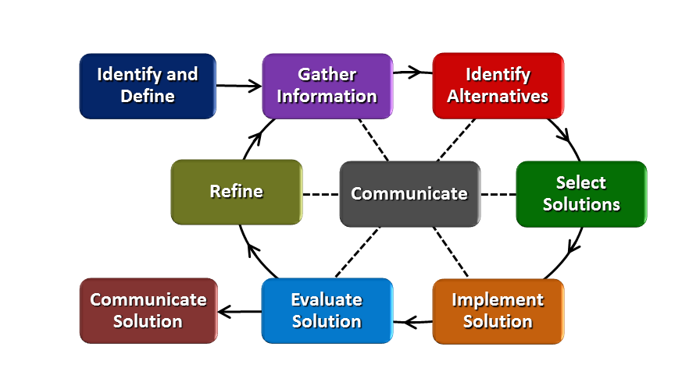
How will students test or implement the solution? What is the evidence that the solution worked? Describe how the iterative process from the EDP applies to your Challenge. How will students present or defend the solution?

Students will create a supply order form and a route map for the UAV. They will begin with several alternatives, then select three to test. They will simulate the results of their route deliveries using a spreadsheet. They will evaluate how many people received aid, and how many people survived / got better. Students will present their solutions to the class after testing, then return to group work to refine their best solutions.

What academic content is being taught through this Challenge?
-Next Gen Disciplinary Core Ideas in Engineering, Technology and the Application of Science
-Earth and Space Science Core idea ESS3B: Natural Hazards

Using the diagram above, identify any places in the EDP where assessments should take place, as it applies to your Challenge. Describe below what kinds of assessment are most appropriate.

What EDP Processes are ideal for conducting an Assessment? (List ones that apply.) | List the type of Assessment (Rubric, Diagram, Checklist, Model, Q/A etc.) Check box to indicate whether it is formative or summative.
Define the Problem  Gather Information  _Design, Test ,Refine Solutions___  _Communicate Solution______ | Big Ideas and Es Qus group handout ☐ X formative ☐ summative  Nat. Hazards Presentation____ ☐ formative X☐ summative  EDP Group Handout_____ X☐ formative ☐ summative  _Presenting Best Design_________ ☐ formative ☐X summative
Check below which characteristic(s) of this Challenge will be incorporated in its implantation using EDP. (Check all that apply.)
X☐ Has clear constraints that limit the solutions
X☐ Will produce more than one possible solution that works
X☐ Includes the ability to refine or optimize solutions
X☐ Assesses science or math content
X☐ Includes Math applications
☐ Involves use of graphs
X☐ Requires analysis of data
X☐ Includes student led communication of findings

5. ACS (Real world applications; career connections; societal impact):
Place an X on the continuum to indicate where this Challenge belongs in the context of real world applications:
Abstract or Loosely Applies to the Real World | |--------------------------------------|-----X----------------------------------| | Strongly Applies to the Real World

Provide a brief rationale for where you placed the X:___Disaster Relief is a real-world problem students will recognize, and UAVs have many applications both currently and in the future.__________
What activities in this Unit apply to real world context? __Activity 2: Natural Hazards; Activity 3: Design a Plan______

Place an X on the continuum to indicate where this Challenge belongs in the context of societal impact:
Shows Little or No Societal Impact | |-------------------------------------|--------------------X--------------------| | Strongly Shows Societal Impact

Provide a brief rationale for where you placed the X: __Disasters disproportionately affect marginalized people; it is our responsibility as society (local and global) to seek ways to protect the health and safety of others. _______

What activities in this Unit apply to societal impact? ____ Activity 3: Design a Plan______

Careers: What careers will you introduce (and how) to the students that are related to the Challenge? (Examples: career research assignment, guest speakers, fieldtrips, Skype with a professional, etc.)
UAV Pilot for Ohio Air National Guard will be a guest speaker.
Students will have the opportunity to read and write about careers in disaster relief.
Aerospace researcher will visit or Skype with the class.

6. Misconceptions:
Misconceptions about Natural Hazards from: MiTEP (Michigan Teaching Excellence Program) List of Common Geoscience Misconceptions
• Natural disasters happen very rarely and these events are just the bad luck of the people that are affected. • Hazards are random in both time and place and just bad luck • All natural disasters have only local effects

Misconceptions about Earth Science by Kent Kirkby, University of Minnesota

http://serc.carleton.edu/NAGTWorkshops/intro/misconception_list.html

Earthquakes:
Earthquakes are rare events (media coverage of earthquakes is limited and biased to U.S. area or high death tolls)
The ground cracks opens during an earthquake to swallow people and buildings (common to Hollywood movies and popular literature like 'Clan of the Cave Bear' and Shogun', but also dates to early reports of Lisbon earthquake and confusion over landslides, etc.).
Earth shaking is deadly (as opposed to building collapse, tsunamis, landslides, fire, etc.)
Seismic waves involve the long distance net motion of particles
Seismic waves go from crust to core, but not core to crust (textbooks seldom specifically discuss second half of journey apart from a general treatment of shadow zones).
S-waves (shear waves) do not reach other side of Earth from where earthquake originated because they cannot pass through oceans (or cannot reach islands).
Wind blowing through subterranean passages causes earthquakes (Aristotle's hypothesis, tied with older cosmology of hollow passages through earth)
Earthquakes occur from collapse of subterranean hollow spaces (tie to older cosmologies).

Volcanoes:
Magma comes from molten layer beneath Earth's crust (older cosmologies, Franklin's idea, as well as popular literature such as Dante's Inferno, and some religious tracts).
Magma comes from deep within Earth's mantle (common textbook and earth science educational movies use of 'deep' terminology, older cosmology of passage-filled Earth')
Magma comes from Earth's outer core (this one tends to increase as students realize there is no molten layer in the mantle).
Volcanic eruptions are rare events (media coverage is biased by location and death tolls).
Volcanoes are dominantly tropical features (Gilligan Island phenomena, common depiction)
Most deaths during volcanic eruptions are due to suffocation from smoke or poisonous gases (older scientific hypothesis until 1902 Pelee eruption, real life knowledge that many deaths in fires due to smoke inhalation, as well as being specifically mentioned as such in secondary education earth science films, all primarily legacy of Pompeii casts).
Most deaths during volcanic eruptions are due to fear and panic during evacuation (real life knowledge of crowds, Hollywood depictions).
Most magma forms as rock melts due to an increase in temperature (in real life this is the way most things melt, coupled with knowledge that temperature rises within Earth).
Most magma forms as rock is subjected to great pressure deep within the Earth (since increased pressure makes rock easier to deform or convect, even greater pressure should turn it to liquid - or so it seems).
Most volcanoes are tall peaks with craters at summit (bias of photographic record, pretty volcanoes most photographed, subduction volcanoes more accessible than submarine)
Whole idea of common use of active, dormant and extinct terms having geologic validity.
Volcanoes are only hazards, not important long-term resources.

7. Unit Lessons and Activities: (Provide a tentative timeline with a breakdown for Lessons 1 and 2. Provide the Lesson #’s and Activity #’s for when the Challenge Based Learning (CBL) and Engineering Design Process (EDP) are embedded in the unit.)

Lesson 1: The Hook; Essential Questions; Natural Hazards (Activity 1 and 2)
This lesson sets the stage for the 2 part challenge in Lesson 2. Students will be introduced to UAV technology through guest speakers, then consider the global concern of Disaster Relief. After identifying Essential Questions and receiving a challenge from the teacher, students will research and make presentations about Natural Hazards and their effects on local and global society.
The Big Idea: Optimization and Disaster Relief

Activity 1: The Hook / Essential Questions brainstorming (Challenge Based Learning)
The hook: Youtube Videos of Major natural disasters, UAV's taking pictures of disaster area or forest fires, Amazon drones with deliveries; classroom visit from Air Guard pilot who flies Predator drone
Essential Question to look for: How can we save the most lives after a natural disaster?

Activity 2: Natural Hazards and Natural Disasters
Using online resources, work with a group to prepare a presentation (Google Slides) on one type of natural hazard (eg: earthquake, hurricane, etc): natural and other causes, historical data, effects on human activity locally and globally.

Lesson 2: The Challenge and the Engineering Design Process (Activities 3 and 4)
This lesson allows students two opportunities to experience the Engineering Design Process. In Activity 3, student groups will be challenged to create a disaster relief plan to use UAVs in delivering supplies. In Activity 4, students will learn how to program NXT robots to simulate their plan.
Activity 3: Design a Plan (Challenge Based Learning and Engineering Design Process)
The Challenge: There has been a natural disaster. We have a map of where people are stranded without supplies, what kinds of supplies are needed, and costs. Your group will need to create a plan for what supplies will be delivered to each location by UAV, in what order. Constraints include a fixed budget and a limited time. How can you provide the most effective aid?
Students will work in small groups to create plans, and use a spreadsheet simulation to compare costs (money and time) vs benefits (people helped) for various plans. Students may need to use some mathematics to calculate distances between coordinates on a map as well. Students will present their plans to classmates and continue to revise / improve.

Activity 4: Robot Simulation (Challenge Based Learning and Engineering Design Process -- this activity may be omitted if NXT Robotics equipment is not available)
The Challenge, part 2: After you have tested and revised your plan, you will work with your team to program an NXT robot to carry out your plan on a large scale (classroom floor size) map of the disaster area. Robots will simulate the UAV deliveries; for each team, costs ($/time) and supply deliveries will be measured to evaluate the effectiveness of the UAV delivery.

CBL: L1A1, L2A3, L2A4
EDP: L2A3, L2A4
Total Unit Time: 13-14 Days
Days 1-5: Lesson 1 - UAVs and Natural Hazards
Activity 1: The Hook, Essential Questions (CBL)
Day 1 (optional): Guest Speakers on UAVs
Day 2: Videos; Hook (Disaster Relief) and Essential Questions (CBL) ; Videos on UAVs and Disaster Relief
Activity 2: Natural Hazards
Day 3: Natural Hazards: What are they?
Day 4-6: Creating and presenting a slide show for one Natural Hazard
Day 7-13 or 14: Lesson 2: Design and Test a Disaster Relief Plan (EDP)
Activity 3: Design and Test a Disaster Relief Plan for UAVs (EDP)
Day 7-8: Design a Plan (following EDP process handout); test alternatives (using a spreadsheet?) for cost and benefit information
Activity 4 (optional): Test Your Design: Programming NXT Robots (EDP, part 2)
Day 9: Building Robots
Day 10: Learning Programming Tools
Day 11-12 Programming and Testing Robots
Day 13-14: Presenting Final UAV Disaster Relief Plan, Running Robot Simulation, evaluating plan
8. Additional Resources:

Websites for Activity 1:
https://www.youtube.com/watch?v=d6hmDaLWFBg 27 sec of Predator surveying to prep for Forest Fire mission
https://www.youtube.com/watch?v=u7K2aJgvpdw Amazon Testing Delivery by Drone
https://www.youtube.com/watch?v=WRrxOfgwFyw Why Amazon Delivery Drones Won’t Work

Day 2: The Hook / The Essential Question
https://www.youtube.com/watch?v=fW2qCK0I6cw 5 min: Top 10 Infamous Natural Disasters - Last 100 Years
https://www.youtube.com/watch?v=sBzHhUnPhRg Red Cross statistics: disasters last year

Websites for Activity 2:
https://www.youtube.com/watch?v=QfmRf8iOBkI 10 most brutal natural disasters of 2011
computers with slide show (Power Point, Google Slides, etc) technology

https://www.e-education.psu.edu/geog030/node/377 Penn State Geography 030 course module on Natural Hazards
Handout to go with Penn State Website
From Dr Cohen:
http://www.popularmechanics.com/science/environment/a9479/line-of-fire-what-happened-at-yarnell-hill-15937170
Supplemental resources a - m: Big Idea and Essential Questions; Natural Hazards; Directions and Rubric for Natural Hazards Presentation, Directions and Rubric for Challenge, Directions for NXT Robots, Handouts for EDP for Challenge Part 1 and 2
Computers with internet and PowerPoint or other Slide Show technology
Robotics kits
PCs with Robotics software
Floor space for driving robots to locations
9. Pre-Unit and Post-Unit Assessment Instruments:
Pretest on Natural Hazards the Engineering Design Process
Post: Rubric for Natural Hazards Presentation; Rubric for Design and Simulation for UAV Disaster Plan; Free response questions on final exam

10. Poster (Link here.) | 11. Video (Link here.)

If you are a science teacher, check the boxes below that apply:
Next Generation Science Standards (NGSS)
Science and Engineering Practices (Check all that apply) | Crosscutting Concepts (Check all that apply)
X☐ Asking questions (for science) and defining problems (for engineering) | ☐ Patterns
X☐ Developing and using models | X☐ Cause and effect
X☐ Planning and carrying out investigations | ☐ Scale, proportion, and quantity
☐ Analyzing and interpreting data | ☐ Systems and system models
☐ Using mathematics and computational thinking | ☐ Energy and matter: Flows, cycles, and conservation
X☐ Constructing explanations (for science) and designing solutions (for engineering) | ☐ Structure and function.
☐ Engaging in argument from evidence | ☐ Stability and change.
X☐ Obtaining, evaluating, and communicating information

If you are a science teacher, check the boxes below that apply:
Ohio’s New Learning Standards for Science (ONLS)
Expectations for Learning - Cognitive Demands (Check all that apply)
X☐ Designing Technological/Engineering Solutions Using Science concepts (T)
X☐ Demonstrating Science Knowledge (D)
X☐ Interpreting and Communicating Science Concepts (C)
X☐ Recalling Accurate Science (R)

If you are a math teacher, check the boxes below that apply:
Common Core State Standards -- Mathematics (CCSS)
Standards for Mathematical Practice (Check all that apply)
X☐ Make sense of problems and persevere in solving them | X☐ Use appropriate tools strategically
☐ Reason abstractly and quantitatively | ☐ Attend to precision
☐ Construct viable arguments and critique the reasoning of others | ☐ Look for and make use of structure
☐ Model with mathematics | ☐ Look for and express regularity in repeated reasoning

Part 2: Post Implementation- Reflection on the Unit
Results: Evidence of Growth in Student Learning - After teaching the Unit, present the evidence below that growth in learning was measured through one the instruments identified above. Show results of assessment data that prove growth in learning occurred.

Please include:
- Any documents used to collect and organize post unit evaluation data. (charts, graphs and /or tables etc.)
- An analysis of data used to measure growth in student learning providing evidence that student learning occurred. (Sentence or paragraph form.)
- Other forms of assessment that demonstrate evidence of learning.
- Anecdotal information from student feedback.

Reflection: Reflect upon the successes and shortcomings of the unit. Refer to the questions posed on the Unit Template Instruction sheet. Describe how the actual Engineering Design Process was actually used in the implementation of the Unit.

Name:Marcia Roth | Contact Info:mroth@ccirish.org | Date:

Lesson Title : The Hook; Essential Questions; Natural Hazards | Unit #: 1 | Lesson #: 1 | Activity #: 1
Activity Title: The Hook: UAVs; Essential Questions

Estimated Lesson Duration: | 5 class periods
Estimated Activity Duration: | 2 class periods (45-50 min)

Setting: | 9th grade Integrated Science Classroom

Activity Objectives:
ETS1.A Defining and Delimiting Engineering Problems
Cross-Cutting Concept: Cause and Effect
“New Technologies can have deep impacts on society and the environment, including some that were not anticipated. Analysis of costs and benefits is a critical aspect of decisions about technology.”

I can identify a major global challenge (natural hazards).
Optional: I can identify three ways UAVs are used today. (recreation, video and photo surveillance, missiles, ...)
Optional: I can identify possible risks and benefits of future developments in UAVs

I can write essential questions about the Big Idea: How can we minimize the losses from Natural Disasters?

Activity Guiding Questions:
Day 1: (Optional)
What is a UAV, and how are UAVs used today?
How can UAVs benefit our society?
What are some possible future developments in UAVs?\

Day 2:
What is a natural hazard?
How do natural hazards affect local and global societies?

Next Generation Science Standards (NGSS)
Science and Engineering Practices (Check all that apply) | Crosscutting Concepts (Check all that apply)
X☐ Asking questions (for science) and defining problems (for engineering) | ☐ Patterns
☐ Developing and using models | X☐ Cause and effect
☐ Planning and carrying out investigations | ☐ Scale, proportion, and quantity
☐ Analyzing and interpreting data | ☐ Systems and system models
☐ Using mathematics and computational thinking | ☐ Energy and matter: Flows, cycles, and conservation
X☐ Constructing explanations (for science) and designing solutions (for engineering) | ☐ Structure and function.
X☐ Engaging in argument from evidence | X☐ Stability and change.
X☐ Obtaining, evaluating, and communicating information

Ohio’s New Learning Standards for Science (ONLS)
Expectations for Learning - Cognitive Demands (Check all that apply)
☐ Designing Technological/Engineering Solutions Using Science concepts (T)
X☐ Demonstrating Science Knowledge (D)
X☐ Interpreting and Communicating Science Concepts (C)
☐ Recalling Accurate Science (R)

Common Core State Standards -- Mathematics (CCSS)
Standards for Mathematical Practice (Check all that apply)
☐ Make sense of problems and persevere in solving them | ☐ Use appropriate tools strategically
☐ Reason abstractly and quantitatively | ☐ Attend to precision
☐ Construct viable arguments and critique the reasoning of others | ☐ Look for and make use of structure
☐ Model with mathematics | ☐ Look for and express regularity in repeated reasoning

Unit Academic Standards (NGSS, ONLS and/or CCSS):

HS-ETS1-1. Analyze a major global challenge to specify qualitative and quantitative criteria and constraints for solutions that account for societal needs and wants.
HS-ETS1-2. Design a solution to a complex real-world problem by breaking it down into smaller, more manageable problems that can be solved through engineering.

Materials: (Link Handouts, Power Points, Resources, Websites, Supplies)
Day 1 - Optional - Guest Speakers on UAV’s
Guest speaker #1: Pilot, Ohio ANG Predator MQ-1 UAV
Guest speaker #2: Aerospace Engineering Professor, UC - UAVs and Forest Fires

Day 2 - Handout: From the Big Idea -> to Essential Questions

https://www.youtube.com/watch?v=d6hmDaLWFBg 27 sec of Predator surveying to prep for Forest Fire mission
https://www.youtube.com/watch?v=u7K2aJgvpdw Amazon Testing Delivery by Drone
https://www.youtube.com/watch?v=WRrxOfgwFyw Why Amazon Delivery Drones Won’t Work

Day 2: The Hook / The Essential Question
https://www.youtube.com/watch?v=fW2qCK0I6cw 5 min: Top 10 Infamous Natural Disasters - Last 100 Years
https://www.youtube.com/watch?v=sBzHhUnPhRg Red Cross statistics: disasters last year

Teacher Advance Preparation:
Preview video links.
Copy handout 1.1.1a Optimization Essential Question Worksheet
(optional) contact guest speakers from the community to share about UAVs
If guest speakers are coming, spend some time with students brainstorming questions. First, spend about 5 minutes explaining the guest speaker’s background and work. Have students write questions in their notebooks and make sure each student has multiple questions. Write several questions on the board to make sure there are not too many duplicates. Possible themes for questions:
How are UAVs used today?
For ANG Pilot:
How many MQ-1s are here in Springfield? Where are the other MQ-1’s you fly?
What is a typical day for an MQ-1 pilot?
What are some ways UAVs may be used in the future? What are some of the risks and benefits? What are career opportunities in these fields?
For UAV Firefighter Researcher:
How many fire departments have used UAVs? How many will use them in the future?
Are UAVs ever used for delivering supplies to firefighters?
What difficulties did you find when you tested your UAVs with real fires? How did you address those?

Activity Procedures:
Day 1 - Optional - Guest Speakers on UAV’s
Guest speaker #1: Pilot, Ohio ANG Predator MQ-1 UAV
Guest speaker #2: Aerospace Engineering Professor, UC - UAVs and Forest Fires
Discussion: Teacher will introduce the guest speakers. Speakers will share for about 10 minutes and then the students will take turns sharing their questions.

Day 2 - Hook and Essential Questions
Introduce the Big Idea on the board: Natural Disasters. Watch 2 videos and have students jot down a few words of their impressions or questions after each.

https://www.youtube.com/watch?v=fW2qCK0I6cw 5 min: Top 10 Infamous Natural Disasters - Last 100 Years
https://www.youtube.com/watch?v=sBzHhUnPhRg Red Cross statistics: disasters last year

Pass out the handout: Big Idea -> Essential Questions -> Challenge

Students will list essential questions - 2 min individually,
10 min in small groups
15 min - large group - How do we pick out the one essential question that drives the Challenge and the rest of the instruction?
- Grouping the “like questions” and eliminating duplicates
- Evaluate - criteria for EQs, evaluate too broad/narrow, How long it takes to answer a question (30 seconds=bad vs 3 decades=good)

Post the Essential Question for the remainder of the Unit.
Tell the class that the Challenge will be announced at the beginning of the following lesson.

If time permits, continue on questions and videos on the back side of the handout.
How can technology help minimize the losses from natural disasters?
Focus for Media Interaction for each video clip: What are the risks and benefits of this approach?
https://www.youtube.com/watch?v=53cBlCfLpZg Lockheed Martin UAV Helicopter: dropping water, supplies, etc
http://map.uaviators.org/nepal/#close map of UAV documentation from Nepal Earthquake; videos at Phalamsangu (location #2)
https://www.youtube.com/watch?v=yZNOlP_sb6k talking head Predators in Wildfire CA -

Handout: Our Challenge (Big Idea --> Essential Questions)

Differentiation: Describe how you modified parts of the Lesson to support the needs of different learners.
Refer to Activity Template for details.

Additional websites for students with extra time or interest in the topic:
http://www.ainonline.com/aviation-news/defense/2013-10-04/predator-uav-helps-fight-fires-california Article to read about Predators Wildfire CA - What can MQ-1 UAVs do to minimize losses from disasters?

http://www.rescue.org/blog/drones-r-us-reflections-use-uavs-humanitarian-interventions UAVS in humanitarian interventions? What are some of the challenges and advantages?
http://map.uaviators.org/nepal/#uavOpenModal UAV Video from Nepal Earthquake
UAViators.org

Reflection: Reflect upon the successes and shortcomings of the lesson.

Name:Marcia Roth | Contact Info:mroth@ccirish.org | Date:

Lesson Title : The Hook; Essential Questions; Natural Hazards | Unit #: 1 | Lesson #: 1 | Activity #: 2
Activity Title: Effects of Natural Hazards

Estimated Lesson Duration: | 4 days
Estimated Activity Duration: | 3 days

Setting: | 9th Grade Integrated Science Classroom

Activity Objectives:

I can create a presentation to show and explain where/why natural hazards have occurred and how they have influenced human activity.

Activity Guiding Questions:
What are three causes of natural hazards? (geological, meteorological, hydrological -- also biological but not considered part of Earth-Space science curriculum)
Where have natural hazards occurred in recent years (eg, past two decades)?
What scientific processes cause natural hazards to occur?
How have natural hazards influenced human activity:
-locally? (in the town/city)
-regionally? (in the state or country)
-globally? (internationally)?

Next Generation Science Standards (NGSS)
Science and Engineering Practices (Check all that apply) | Crosscutting Concepts (Check all that apply)
X☐ Asking questions (for science) and defining problems (for engineering) | ☐ Patterns
☐ Developing and using models | X☐ Cause and effect
☐ Planning and carrying out investigations | ☐ Scale, proportion, and quantity
X☐ Analyzing and interpreting data | ☐ Systems and system models
☐ Using mathematics and computational thinking | ☐ Energy and matter: Flows, cycles, and conservation
X☐ Constructing explanations (for science) and designing solutions (for engineering) | ☐ Structure and function.
X☐ Engaging in argument from evidence | ☐ Stability and change.
X☐ Obtaining, evaluating, and communicating information

Ohio’s New Learning Standards for Science (ONLS)
Expectations for Learning - Cognitive Demands (Check all that apply)
☐ Designing Technological/Engineering Solutions Using Science concepts (T)
X☐ Demonstrating Science Knowledge (D)
X☐ Interpreting and Communicating Science Concepts (C)
☐ Recalling Accurate Science (R)

Common Core State Standards -- Mathematics (CCSS)
Standards for Mathematical Practice (Check all that apply)
☐ Make sense of problems and persevere in solving them | ☐ Use appropriate tools strategically
☐ Reason abstractly and quantitatively | ☐ Attend to precision
☐ Construct viable arguments and critique the reasoning of others | ☐ Look for and make use of structure
☐ Model with mathematics | ☐ Look for and express regularity in repeated reasoning

Unit Academic Standards (NGSS, ONLS and/or CCSS):

HS-ESS3-1 Construct an explanation based on evidence for how the occurrence of natural hazards have influenced human activity.

Materials: (Link Handouts, Power Points, Resources, Websites, Supplies)
https://www.youtube.com/watch?v=sBzHhUnPhRg Red Cross statistics: disasters last year
https://www.youtube.com/watch?v=QfmRf8iOBkI 10 most brutal natural disasters of 2011
computers with slide show (Power Point, Google Slides, etc) technology

https://www.e-education.psu.edu/geog030/node/377 Penn State Geography 030 course module on Natural Hazards
Handout to go with Penn State Website
Teacher Advance Preparation:
Preview video links.
Prepare handouts.
Reserve computers.
Review Penn State Website, Geography 030 Module 8 (Natural Hazards).

Activity Procedures:

Day 1:
Motivation: Our Challenge (last part of handout from lesson 1.1.1 The Hook /EQs - Have students write down the Challenge: Create a plan for delivering supplies after a natural disaster.
Guiding Questions:
-What are the causes and effects of Natural Disasters?

Introduce first two videos: What are Natural Hazards? What relief help is needed?

What are Natural Hazards?
Have students list some examples. (volcanic eruptions, earthquakes, tsunamis, mass wasting, soil erosion, hurricanes, floods, droughts)
Have students review Penn State Website, Geography 030 Module 8 (Natural Hazards) and answer the worksheet questions. (25 minutes)
Divide students into groups -- each group will be assigned one type of natural disaster / hazard. Students will have 2 days to prepare a slide show, 4 slides each group:

- Name of Natural Hazard, with picture.
- Type of Natural Process, with brief explanation of how natural process causes this hazard and how human activity may contribute
- Example of this Natural Hazard from history - with picture and facts: date, location, damage statistics
- How has this natural hazard influenced human activity?
-locally? (in the town/city)
-regionally? (in the state or country)
-globally? (internationally)?

Worksheet 1.1.2c: Natural Hazards Overview

Handout 1.1.2d: Rubric for Slide Show

Differentiation: Describe how you modified parts of the Lesson to support the needs of different learners.
Refer to Activity Template for details.

Ramp up - some students may move on to the “extension” questions on the Natural Hazards Overview WS
Some students may only need to complete 2 of the 4 types of Natural Hazards

Reflection: Reflect upon the successes and shortcomings of the lesson.

Name: Marcia Roth | Contact Info: mroth@ccirish.org | Date:

Lesson Title : The Challenge and the Engineering Design Process | Unit #: 1 | Lesson #: 2 | Activity #: 1
Activity Title: Design a Plan

Estimated Lesson Duration: | 8 days
Estimated Activity Duration: | 3 days

Setting: | 9th Grade Integrated Science Classroom

Activity Objectives:
Design a plan to optimize the use of UAVs in a disaster relief situation.
-Work through the steps of the Engineering Design Process: Identify challenge, gather information, identify/select/test alternatives, revise and continue, communicate.

Activity Guiding Questions:
Guiding Questions:
How far and how fast can a UAV travel?
What types of supplies can a UAV carry?
How much distance can the UAV travel in 24 hours? How many locations can it reach?
How can we minimize travel time and travel distance?
Which supplies should be delivered first? Why?

Next Generation Science Standards (NGSS)
Science and Engineering Practices (Check all that apply) | Crosscutting Concepts (Check all that apply)
☐ Asking questions (for science) and defining problems (for engineering) | ☐ Patterns
X☐ Developing and using models | X☐ Cause and effect
X☐ Planning and carrying out investigations | X☐ Scale, proportion, and quantity
X☐ Analyzing and interpreting data | X☐ Systems and system models
X☐ Using mathematics and computational thinking | ☐ Energy and matter: Flows, cycles, and conservation
X☐ Constructing explanations (for science) and designing solutions (for engineering) | ☐ Structure and function.
☐ Engaging in argument from evidence | ☐ Stability and change.
X☐ Obtaining, evaluating, and communicating information

Ohio’s New Learning Standards for Science (ONLS)
Expectations for Learning - Cognitive Demands (Check all that apply)
X☐ Designing Technological/Engineering Solutions Using Science concepts (T)
☐ Demonstrating Science Knowledge (D)
☐ Interpreting and Communicating Science Concepts (C)
☐ Recalling Accurate Science (R)

Common Core State Standards -- Mathematics (CCSS)
Standards for Mathematical Practice (Check all that apply)
X☐ Make sense of problems and persevere in solving them | X☐ Use appropriate tools strategically
☐ Reason abstractly and quantitatively | X☐ Attend to precision
☐ Construct viable arguments and critique the reasoning of others | ☐ Look for and make use of structure
X☐ Model with mathematics | ☐ Look for and express regularity in repeated reasoning

Unit Academic Standards (NGSS, ONLS and/or CCSS):
HS-ETS1-2. Design a solution to a complex real-world problem by breaking it down into smaller, more manageable problems that can be solved through engineering.
HS-ETS1-3. Evaluate a solution to a complex real-world problem based on prioritized criteria and trade-offs that account for a range of constraints, including cost, safety, reliability, and aesthetics as well as possible social, cultural, and environmental impacts.
HS-ETS1-4. Use a computer simulation to model the impact of proposed solutions to a complex real-world problem with numerous criteria and constraints on interactions within and between systems relevant to the problem.

Materials: (Link Handouts, Power Points, Resources, Websites, Supplies)
PowerPoint to Introduce the Challenge
Handout: Design a Plan (Engineering Design Process)
Handout: Disaster circumstances
Excel / Google Sheets worksheet - Computer Simulation

Teacher Advance Preparation:
Set up the PowerPoint.
Copy the Handouts.
Review the spreadsheet to become familiar with the calculations.

Activity Procedures:

Day 1: The Challenge / the Engineering Design Process

Explain the challenge to students, using the PowerPoint;
There has been an earthquake. We have a map of where people are stranded without supplies. Your group will need to create a plan for what supplies will be delivered to each location by UAV, in what order. How can you provide the most effective aid?
For Activity 2, your group will program a robot to simulate these tasks.

Explain the challenge. Pass out the map worksheet with the disaster specifications. Assign students to groups of 4. Group roles will be assigned (recorder, manager, timekeeper, fact checker)

Refer to the poster (or PowerPoint Slide) of the Engineering Design Process. Explain the steps to the students

Pass out the “Design a Plan” (EDP) Handout. Have students follow the process in steps 1 and 2.

Step 1: 5 minutes - identify the challenge in your own words.

During Step 2 (gather information), have students review the disaster specifications to brainstorm some guiding questions. (10 minutes)
List examples on the board (5 minutes)
Examples of Guiding Questions:
How far and how fast can the UAV travel?
What types of supplies can the UAV carry?
How much distance can the UAV travel in 24 hours? How many locations can it reach?
How can we minimize travel time and travel distance?
Which supplies should be delivered first? Why?

Check with the teacher (use cups or flag signal) when you have completed these steps. As groups are checked by the teacher:
Pass out the “Disaster Specifications with Map” handout with information about the needs of the people at each location, distances between locations, speed and carrying capacity of UAVs.

Instruct students to begin Step 3 (Design Solutions) by brainstorming strategies for delivering supplies. Brainstorming means ideas are not judged, only recorded. (5 minutes)

For Step 4 (Select Solutions), groups should choose three of their best ideas and write about pros and cons of each strategy. (15 minutes)

Check with the teacher (use cups or flag signal) when you have completed these steps. If time still remains, groups may begin to calculate the distance, supplies delivered, people saved by their plan.

DAY 2: Testing and Communicating

For Step 5, students will write out their best plan on the whiteboards and test it by calculating distance traveled, time spent, supplies delivered, and people helped. (15 minutes)

After each group has tested their plan, groups will report back to the whole class. They will explain why their strategy was chosen, advantages, and the outcomes. (15 minutes)

After walking around to hear about all the plans, groups will return to their tables and have the opportunity to revise their plans based on their own data and reports from their classmates.

DAY 3: (Optional) Computer Simulation

Using the Google Sheet shared with all the students, groups will continue to test their plans and complete the data table for step 6 in their handouts. The spreadsheet simulation will allow them to test and revise while making calculations quickly.

FORMATIVE ASSESSMENTS:
EDP Handout, completed
Presentation to class of Design and Results

Differentiation: Describe how you modified parts of the Lesson to support the needs of different learners.
Refer to Activity Template for details.

Reflection: Reflect upon the successes and shortcomings of the lesson.

Name: Marcia Roth | Contact Info: mroth@ccirish.org | Date:

Lesson Title : The Challenge and the Engineering Design Process | Unit #: 1 | Lesson #:2 | Activity #:4
Activity Title: Robot Simulation

Estimated Lesson Duration: | 8 days
Estimated Activity Duration: | 5 days

Setting: | 9th Grade Integrated Science Classroom

Activity Objectives:

Work with a team to build and program NXT robots to simulate a disaster relief plan for UAVs.

Activity Guiding Questions:
How do I build an NXT robot and make it work?
How do I program a robot to travel a specific distance?
How do I program a robot to turn directions?
How do I figure out how far and in what direction the robot needs to go?

Next Generation Science Standards (NGSS)
Science and Engineering Practices (Check all that apply) | Crosscutting Concepts (Check all that apply)
☐ Asking questions (for science) and defining problems (for engineering) | ☐ Patterns
X☐ Developing and using models | ☐ Cause and effect
X☐ Planning and carrying out investigations | ☐ Scale, proportion, and quantity
☐ Analyzing and interpreting data | ☐ Systems and system models
☐ Using mathematics and computational thinking | ☐ Energy and matter: Flows, cycles, and conservation
☐ Constructing explanations (for science) and designing solutions (for engineering) | ☐ Structure and function.
☐ Engaging in argument from evidence | ☐ Stability and change.
☐ Obtaining, evaluating, and communicating information

Ohio’s New Learning Standards for Science (ONLS)
Expectations for Learning - Cognitive Demands (Check all that apply)
X☐ Designing Technological/Engineering Solutions Using Science concepts (T)
☐ Demonstrating Science Knowledge (D)
☐ Interpreting and Communicating Science Concepts (C)
☐ Recalling Accurate Science (R)

Common Core State Standards -- Mathematics (CCSS)
Standards for Mathematical Practice (Check all that apply)
X☐ Make sense of problems and persevere in solving them | X☐ Use appropriate tools strategically
☐ Reason abstractly and quantitatively | X☐ Attend to precision
☐ Construct viable arguments and critique the reasoning of others | ☐ Look for and make use of structure
☐ Model with mathematics | ☐ Look for and express regularity in repeated reasoning

Unit Academic Standards (NGSS, ONLS and/or CCSS):
HS-ETS1-4. Use a computer simulation to model the impact of proposed solutions to a complex real-world problem with numerous criteria and constraints on interactions within and between systems relevant to the problem.

Materials: (Link Handouts, Power Points, Resources, Websites, Supplies)
Handout i: NXT Robots Instructions
Handout j: Engineering Design Process: Building Robots
Handout k: Map (with coordinates) of disaster area
Teacher handout l: Map of disaster area, scaled to floor
Handout m: Evaluation and Rubric
Spreadsheet h (from Activity 3): Disaster Relief Simulation
NXT Robotics kits: 1 per 2 students
Computers loaded with NXT Robotics software: 1 per 2 students
Floor space marked with a map of the disaster area

Teacher Advance Preparation:
Mark the floor space with a map of the disaster area. (see teacher handout)
Gather NXT Robotics kits and make sure all the parts are present for each kit.
Set up computers with NXT software in a convenient location (ideally with work tables for building robots)
Copy handouts i, j, k, and m for students.
Prepare Spreadsheet h for use on Day 5.

Activity Procedures:
Day 1: Pass out the Engineering Design Process: Robot Simulation. Students will complete this handout individually as they go through the process of the Robot Simulation and turn this in at the end for a Summative Assessment.
Have the students complete Stage 1: Identify and define the Challenge; Stage 2: Gather Information. (students should identify that they need to learn how to build and program the robots, but they already have created plans for what the robots will do in the disaster simulation.)
Students will assemble the NXT Robots. (see directions)

Day 2: Students will learn the basics of NXT programming code. (see handout)

Day 3-4: Pass out and go over the Evaluation Sheet and Grading Rubric.
Students will work in teams to program their robots to travel the disaster relief plan they created. Students should start by brainstorming alternatives for how they will approach the programming challenge, then select 3 alternatives, rate pros and cons. Then students may begin programming the robots and testing their programs. Students should record evaluations and iterations on their handouts as they modify their programs. Once groups are satisfied with their programs, they should complete the first part of the Evaluation Sheet.

Day 5: Presenting / Demonstrations
Each group will explain how they created their disaster plan and the reasons / evidence they believe it will be effective. Two students will execute the robots’ programming while 1 student enters their plan into the spreadsheet simulation. Results of robot simulation and data from spreadsheet will be observed and recorded. After each group has presented, groups will spend a few minutes evaluating their results and suggesting revision.

Students will be formatively assessed using informal teacher check-ins during group work throughout Days 1-4.

EDP Building Robots Handout
Rubric: Robot Performance and Discussion - Document 1.2.4m

Differentiation: Describe how you modified parts of the Lesson to support the needs of different learners.
Refer to Activity Template for details.

Reflection: Reflect upon the successes and shortcomings of the lesson.

APPENDIX4 CODE FOR 2-OPT IN MATLAB®
% @@@@@@@@@@@@@@@@@@@@@@@@@@@@@@@@@@@@@@@@@@@@@@@@@@@@@@@@@@@@@@@@@@@@@@@@@
% @@@@ @@@@
% @@@@ PREPARED BY ANOOP SATHYAN @@@@
% @@@@ @@@@
% @@@@@@@@@@@@@@@@@@@@@@@@@@@@@@@@@@@@@@@@@@@@@@@@@@@@@@@@@@@@@@@@@@@@@@@@@

n = 100; %Set the number of cities
%xy = 10*rand(n,2); %Randomise the positions of cities
num_iter = 20; % Number of iterations
a = meshgrid(1:n);
dmat = reshape(sqrt(sum((xy(a,:)-xy(a',:)).^2,2)),n,n); %Distance Matrix
opt_rte = [1:1:n];
newopt = opt_rte; %Initial Tour
newopt(n+1) = opt_rte(1); %Should return to the starting position.
plot(xy(:,1),xy(:,2),'r.');
pfig = figure('Name','Current Best Solution','Numbertitle','off');

for iter = 1:num_iter,
for i = 1:n-2,
for j = i+2:n
,
d1 = dmat(newopt(i),newopt(i+1)) + dmat(newopt(j),newopt(j+1));
d2 = dmat(newopt(i),newopt(j)) + dmat(newopt(i+1),newopt(j+1));
if d1 > d2 %Compare the distances
[newopt(j),newopt(i+1)] = deal(newopt(i+1),newopt(j)); %Swap move.
else
end
if i == 1,
newopt(n+1) = newopt(1);
elseif (i == n)||(j == n)
newopt(1) = newopt(n+1);
end
end
end
end
optresult = newopt(1:n);
xy_opt = xy(optresult,:);
xy_opt(n+1,:) = xy(optresult(1),:);
distance = 0;
for ii = 1:n-1,
distance = distance + dmat(optresult(ii),optresult(ii+1));
end
total_distance = distance + dmat(optresult(1),optresult(n));
figure(pfig)
plot(xy_opt(:,1),xy_opt(:,2),'r.-')
title(sprintf('Distance = %f',total_distance))

APPENDIX5: CODE FOR GENETIC ALGORITHM IN MATLAB®

function varargout = tsp_ga(xy,dmat,pop_size,num_iter,stall,show_prog,show_res)
%TSP_GA Traveling Salesman Problem (TSP) Genetic Algorithm (GA)
% Finds a (near) optimal solution to the TSP by setting up a GA to search
% for the shortest route (least distance for the salesman to travel to
% each city exactly once and return to the starting city)
%
% Summary:
% 1. A single salesman travels to each of the cities and completes the
% route by returning to the city he started from
% 2. Each city is visited by the salesman exactly once
%
% Input:
% XY (float) is an Nx2 matrix of city locations, where N is the number of cities
% DMAT (float) is an NxN matrix of point to point distances/costs
% POP_SIZE (scalar integer) is the size of the population (should be divisible by 4)
% NUM_ITER (scalar integer) is the number of desired iterations for the algorithm to run
% SHOW_PROG (scalar logical) shows the GA progress if true
% SHOW_RES (scalar logical) shows the GA results if true
%
% Output:
% OPT_RTE (integer array) is the best route found by the algorithm
% MIN_DIST (scalar float) is the cost of the best route
%
% 2D Example:
% n = 50;
% xy = 10*rand(n,2);
% pop_size = 60;
% num_iter = 1e4;
% show_prog = 1;
% show_res = 1;
% a = meshgrid(1:n);
% dmat = reshape(sqrt(sum((xy(a,:)-xy(a',:)).^2,2)),n,n);
% [opt_rte,min_dist] = tsp_ga(xy,dmat,pop_size,num_iter,show_prog,show_res);
%
% 3D Example:
% n = 50;
% xyz = 10*rand(n,3);
% pop_size = 60;
% num_iter = 1e4;
% show_prog = 1;
% show_res = 1;
% a = meshgrid(1:n);
% dmat = reshape(sqrt(sum((xyz(a,:)-xyz(a',:)).^2,2)),n,n);

% [opt_rte,min_dist] = tsp_ga(xyz,dmat,pop_size,num_iter,show_prog,show_res);
%
% See also: mtsp_ga, tsp_nn, tspo_ga, tspof_ga, tspofs_ga, distmat
%
% Author: Joseph Kirk
% Email: jdkirk630@gmail.com
% Release: 2.2
% Release Date: 6/2/09

% Process Inputs and Initialize Defaults
nargs = 6;
for k = nargin:nargs-1
switch k
case 0
xy = 10*rand(50,2);
case 1
N = size(xy,1);
a = meshgrid(1:N);
dmat = reshape(sqrt(sum((xy(a,:)-xy(a',:)).^2,2)),N,N);
case 2
pop_size = 100;
case 3
num_iter = 1e4;
case 4
show_prog = 1;
case 5
show_res = 1;
otherwise
end
end

% Verify Inputs
[N,dims] = size(xy);
[nr,nc] = size(dmat);
if N ~= nr || N ~= nc
error('Invalid XY or DMAT inputs!')
end
n = N;

% Sanity Checks
pop_size = 4*ceil(pop_size/4);
num_iter = max(1,round(real(num_iter(1))));
show_prog = logical(show_prog(1));
show_res = logical(show_res(1));

% Initialize the Population
pop = zeros(pop_size,n);
for k = 1:pop_size
pop(k,:) = randperm(n);
end

% Run the GA
global_min = Inf;
total_dist = zeros(1,pop_size);
%dist_history = zeros(1,num_iter);
tmp_pop = zeros(4,n);
new_pop = zeros(pop_size,n);
if show_prog
pfig = figure('Name','TSP_GA | Current Best Solution','Numbertitle','off');
end
for iter = 1:num_iter
% Evaluate Each Population Member (Calculate Total Distance)
for p = 1:pop_size
d = dmat(pop(p,n),pop(p,1)); % Closed Path
for k = 2:n
d = d + dmat(pop(p,k-1),pop(p,k));
end
total_dist(p) = d;
end

% Find the Best Route in the Population
[min_dist,index] = min(total_dist);
dist_history(iter) = min_dist;
if min_dist < global_min
global_min = min_dist;
opt_rte = pop(index,:);
if show_prog
% Plot the Best Route
figure(pfig);
rte = opt_rte([1:n 1]);
if dims == 3, plot3(xy(rte,1),xy(rte,2),xy(rte,3),'r.-');
else plot(xy(rte,1),xy(rte,2),'r.-'); end
title(sprintf('Total Distance = %1.4f, Iteration = %d',min_dist,iter));
end
end

% Genetic Algorithm Operators
rand_pair = randperm(pop_size);
for p = 4:4:pop_size
rtes = pop(rand_pair(p-3:p),:);
dists = total_dist(rand_pair(p-3:p));
[ignore,idx] = min(dists);
best_of_4_rte = rtes(idx,:);
ins_pts = sort(ceil(n*rand(1,2)));
I = ins_pts(1);
J = ins_pts(2);
for k = 1:4 % Mutate the Best to get Three New Routes
tmp_pop(k,:) = best_of_4_rte;
switch k
case 2 % Flip
tmp_pop(k,I:J) = fliplr(tmp_pop(k,I:J));
case 3 % Swap
tmp_pop(k,[I J]) = tmp_pop(k,[J I]);
case 4 % Slide
tmp_pop(k,I:J) = tmp_pop(k,[I+1:J I]);
case 5 % Twoopt

otherwise % Do Nothing
end
end
new_pop(p-3:p,:) = tmp_pop;
end
pop = new_pop;
if iter > stall %stall function
if sum(abs(diff(dist_history(iter-stall:iter))))<0.01
break
end
end

end

if show_res
% Plots the GA Results
figure('Name','TSP_GA | Results','Numbertitle','off');
subplot(2,2,1);
if dims == 3, plot3(xy(:,1),xy(:,2),xy(:,3),'k.');
else plot(xy(:,1),xy(:,2),'k.'); end
title('City Locations');
subplot(2,2,2);
imagesc(dmat(opt_rte,opt_rte));
title('Distance Matrix');
subplot(2,2,3);
rte = opt_rte([1:n 1]);
if dims == 3, plot3(xy(rte,1),xy(rte,2),xy(rte,3),'r.-');
else plot(xy(rte,1),xy(rte,2),'r.-'); end
title(sprintf('Total Distance = %1.4f',min_dist));
subplot(2,2,4);
plot(dist_history,'b','LineWidth',2);
title('Best Solution History');
set(gca,'XLim',[0 num_iter+1],'YLim',[0 1.1*max([1 dist_history])]);
end

% Return Outputs
if nargout
varargout{1} = opt_rte;
varargout{2} = min_dist;
end

